**Template for Essay Type Item**

**Subject: Mathematics**

**Domain: D-Geometry**

**Grade: 7**

**Unit: 9. Geometry**

**Type of Assessment: Formative**

**SLO: (M-07-D-01)** Recognize quadrilaterals and their characteristics (parallel sides, equal sides, equal angles, right angles, lines of symmetry etc). (Square, rectangle parallelogram, rhombus, trapezium and kite).

**Type of Task:** Constructed response

**Level of SLO:** Comprehension

**Task:** Calculate unknown angles of the triangles. **(05) Marks**

Ao

49o

45o

**Level of Item:** comprehension

|  |  |  |
| --- | --- | --- |
| **Expected Response** | **Skill observed** | **Score** |
| The sum of the triangle is 180o.  A+B+C= 180o  A=?, B = 49o , C= 45o  A+ 49o + 45o = 180o  A+ 94o = 180o  A= 180o-94o  A= 86o | 1) Formula  2) Calculation  3) Answer | 02 Marks  02 Marks  01 Mark |

**Name and Signature of Developer**

**Zubair Mustafa**

**Reviewer Comments: __________________________________________________________________________________________________________________________________________________________________________________________________________________________________________**

**Name and Signature of Reviewer**

**Template for Essay Type Item**

**Subject: Mathematics**

**Domain: D-Geometry**

**Grade: 7**

**Unit: 9. Geometry**

**Type of Assessment: Formative**

**SLO: (M-07-D-05)** Describe the properties of a circle: centre, radius, diameter, chord, arcs, major and minor arc, semi – circle and segment of a circle.

**Type of Task:** Constructed response

**Level of SLO:** Comprehension

**Task:** Write the formula (i) radius of the circle (ii) diameter? **(04) Marks**

**Level of Item:** Comprehension

|  |  |  |
| --- | --- | --- |
| **Expected Response** | **Skill observed** | **Score** |
| The distance between the centre of the circle to its circumference is the radius.  The diameter is always double the radius.  D | Knowledge of the geometry | 04 Marks |

**Name and Signature of Developer**

**Zubair Mustafa**

**Reviewer Comments: ____________________________________________________________________________________________________________________________________________________________**

**Name and Signature of Reviewer**

**Template for Essay Type Item**

**Subject: Mathematics**

**Domain: D-Geometry**

**Grade: 7**

**Unit: 9. Geometry**

**Type of Assessment: Formative**

**SLO: (M-07-D-07)** Understand the relationship between interior and exterior angles of polygons and between opposite interior and exterior angles in a triangle. **(M-07-D-02)** Differentiate between convex and concave polygons.

**Type of Task:** Constructed response

**Level of SLO:** Comprehension

**Task:** Measure the interior angle of a polygon (square). **(05) Marks**

**Level of Item:** Comprehension

|  |  |  |
| --- | --- | --- |
| **Expected Response** | **Skill observed** | **Score** |
| Formula is          = 90o | 1. Formula 2. Calculation 3. Answer | 01 Mark  03 Marks  01 Mark |

**Name and Signature of Developer**

**Zubair Mustafa**

**Template for Essay Type Item**

**Subject: Mathematics**

**Domain: D-Geometry**

**Grade: 7**

**Unit: 9. Geometry**

**Type of Assessment: Formative**

**SLO: (M-07- D-08)** Calculate the interior and exterior angles of a polygon and the sum of interior angles of a polygon.

**Type of Task:** Constructed response

**Level of SLO:** Comprehension

**Task:** Find the unknown quantity. **(05) Marks**

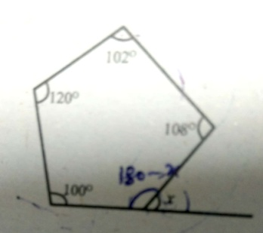

**Level of Item:** Comprehension

|  |  |  |
| --- | --- | --- |
| **Expected Response** | **Skill observed** | **Score** |
| Sum of interior angles of pentagon= | 1. Formula 2. Calculation 3. Answer | (02) Marks  (02) Marks  (01) Mark |

**Name and Signature of Developer**

**Zubair Mustafa**

**Template for Essay Type Item**

**Subject: Mathematics**

**Domain: D-Geometry**

**Grade: 7**

**Unit: 9. Geometry**

**Type of Assessment: Formative**

**SLO: (M-07-D-06)** Calculate unknown angles in quadrilaterals using the properties of quadrilaterals. (Square, rectangle, parallelogram, rhombus, trapezium and kite). **(M-07- D-09)** Recognize identify and draw lines of symmetry in 2-D shapes and rotate objects using rotational symmetry, and find the order of rotational symmetry.

**Type of Task:** Constructed response

**Level of SLO:** Comprehension

**Task:** Find the value of $x$ in the following parallelogram. **(05) Marks**

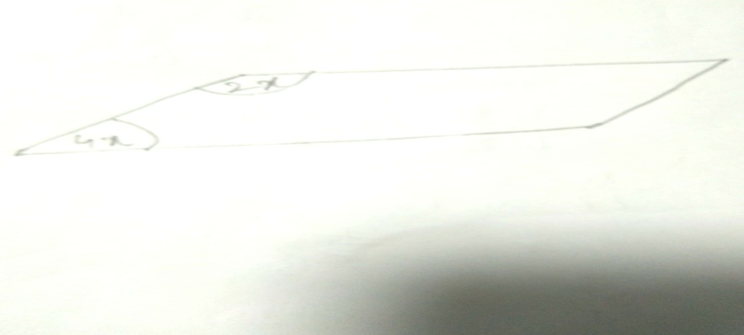

**Level of Item:** Comprehension

|  |  |  |
| --- | --- | --- |
| **Expected Response** | **Skill observed** | **Score** |
| Adjacent angles in a parallelogram add up to ${180}^{o}$ $4x+2x$ = ${180}^{o}$ $6x$ = ${180}^{o}$ $\frac{6x}{6}$ = $\frac{{180}^{o}}{6}$ $$x={30}^{o}$$ | 1) Formula  2) Calculation  3) Answer | (01) Mark  (03) Marks  (01) Mark |

**Name and signature of Developer**

**Zubair Mustafa**

**Reviewer Comments: __________________________________________________________________________________________________________________________________________________________________________________________________________________________________________**