**Template for Essay Type Item**

**Subject: Mathematics**

**Domain: B-Algebra**

**Grade: 7**

**Unit: 8. Linear Equations**

**Type of Assessment: Formative**

**SLO: (M-07-B-16)** Construct linear equations in two variables such as; , where a and b are not zero.

**Type of Task:** Constructed response

**Level of SLO:** Comprehension

**Task:** Find two positive integers whose sum is 10. **(05) Marks**

**Level of Item:** Comprehension

|  |  |  |
| --- | --- | --- |
| **Expected Response** | **Skill Observed** | **Score** |
| Let one number be  and the second number be  then:    If  Hence is a solution of the equation  Similarly,  Hence  is another solution of the equation  Similarly,  are also solutions of the given equation.  Note: A linear equation in two variables may have infinite number of solutions. | 1. Equation 2. Calculations/ simplify 3. Answer | 02 Marks  02 Marks  01 Mark |

**Name and Signature of Developer**

**Zubair Mustafa**

**Reviewer Comments: ____________________________________________________________________________________________________________________________________________________________**

**Name and Signature of Reviewer**

**Template for Essay Type Item**

**Subject: Mathematics**

**Domain: B-Algebra**

**Grade: 7**

**Unit: 8. Linear Equations**

**Type of Assessment: Formative**

**SLO: (M-07-B-16)** Construct linear equations in two variables such as; , where a and b are not zero.

**Type of Task:** Constructed response

**Level of SLO:** Comprehension

**Task:** Which ordered pair is a solution of? **(05) Marks**

1. (2, 4) (ii) (4, 2)

**Level of Item:** Comprehension

|  |  |  |
| --- | --- | --- |
| **Expected Response** | **Skill Observed** | **Score** |
| (i) Test (2, 4): , it means the values of  and  given, put these values in given equation we get    (ii) Test (4, 2): , it means the values of  and given, put these values in given equation we get    So (2, 4) is a solution of. | 1. Substitute the values 2. Calculations/ simplify 3. Answer | 1. Marks   02 Marks    01 Mark |

**Name and Signature of Developer**

**Zubair Mustafa**

**Reviewer Comments: ____________________________________________________________________________________________________________________________________________________________**

**Name and Signature of Reviewer**

**Template for Essay Type Item**

**Subject: Mathematics**

**Domain: B-Algebra**

**Grade: 7**

**Unit: 8. Linear Equations**

**Type of Assessment: Formative**

**SLO: (M-07-B-17)** Recall solving linear equations in one variable.

**Type of Task:** Constructed response

**Level of SLO:** Comprehension

**Task:** Solve linear equation  **(05) Marks**

**Level of Item:** Comprehension

|  |  |  |
| --- | --- | --- |
| **Expected Response** | **Skill Observed** | **Score** |
| Given equation is | 1. Calculations/ simplify 2. Answer | 04 Marks  01 Mark |

**Name and Signature of Developer**

**Zubair Mustafa**

**Reviewer Comments: ____________________________________________________________________________________________________________________________________________________________**

**Name and Signature of Reviewer**

**Template for Essay Type Item**

**Subject: Mathematics**

**Domain: B-Algebra**

**Grade: 7**

**Unit: 8. Linear Equations**

**Type of Assessment: Formative**

**SLO: (M-07-B-17)** Recall solving linear equations in one variable.

**Type of Task:** Constructed response

**Level of SLO:** Application

**Task:** Find the two consecutive numbers whose sum is 21. **(05) Marks**

**Level of Item:** Application

|  |  |  |
| --- | --- | --- |
| **Expected Response** | **Skill Observed** | **Score** |
| Let the two consecutive numbers be  and , then by the given condition    If , then  Thus required numbers are 10 and 11. | 1. Equation 2. Calculations/ simplify 3. Answer | 02 Marks  02 Marks  01 Mark |

**Name and Signature of Developer**

**Zubair Mustafa**

**Reviewer Comments: ____________________________________________________________________________________________________________________________________________________________**

**Name and Signature of Reviewer**

**Template for Essay Type Item**

**Subject: Mathematics**

**Domain: B-Algebra**

**Grade: 7**

**Unit: 8. Linear Equations**

**Type of Assessment: Formative**

**SLO: (M-07-B-21)** Find values of x and y from the graph and solve simultaneous linear equations using eliminations and substitution methods.

**Type of Task:** Constructed response

**Level of SLO:** Comprehension

**Task:** Solve the following system of equations by elimination method. **(05) Marks**



**Level of Item:** Comprehension

|  |  |  |
| --- | --- | --- |
| **Expected Response** | **Skill Observed** | **Score** |
| Step (A):    Step (B):  To eliminate  in both equations, coefficients of  should be equal. To make the coefficient of  equal, multiply equation (1) by 5. | 1. Eliminate 2. Calculations/ simplify 3. Answer | 02 Marks  02 Marks  01 Marks |
| Step (C):  Subtract equation (2) from equation (3) |  |  |
|  |
| Step (D):  Divided both sides by 7    Step (E):  Put in equation (2)    Check: Substituting,  into equation (1) or (2). |

**Name and Signature of Developer**

**Zubair Mustafa**

**Reviewer Comments: ____________________________________________________________________________________________________________________________________________________________**

**Name and Signature of Reviewer**

**Template for Essay Type Item**

**Subject: Mathematics**

**Domain: B-Algebra**

**Grade: 7**

**Unit: 8. Linear Equations**

**Type of Assessment: Formative**

**SLO: (M-07-B-21)** Find values of x and y from the graph and solve simultaneous linear equations using eliminations and substitution methods.

**Type of Task:** Constructed response

**Level of SLO:** Comprehension

**Task:** Solve the following system of equations by substitution method. **(05) Marks**



**Level of Item:** Comprehension

|  |  |  |
| --- | --- | --- |
| **Expected Response** | **Skill Observed** | **Score** |
| Step (A):    Step (B):  Select either of the two equations and find the value of one variable say, in terms of the other that is. By (1) | 1. Substitution 2. Calculations/ simplify 3. Answer | 02 Marks  02 Marks  01 Marks |
| Step (C):  Substitute equation (3) in equation (2) |  |  |
| Step (D):  Substituting  into equation (3). |  |  |

**Name and Signature of Developer**

**Zubair Mustafa**

**Reviewer Comments: __________________________________________________________________________________________________________________________________________________________________________________________________________________________________________**

**Name and Signature of Reviewer**

**Template for Essay Type Item**

**Subject: Mathematics**

**Domain: B-Algebra**

**Grade: 7**

**Unit: 8. Linear Equations**

**Type of Assessment: Formative**

**SLO: (M-07-B-20)** Recognize and state the equation of a horizontal line and a vertical line.

**Type of Task:** Constructed response

**Level of SLO:** Comprehension

**Task:** Sketch the graph of the equations. (i)  (Horizontal line) (ii)  (vertical line).

**(05) Marks**

**Level of Item:** Comprehension

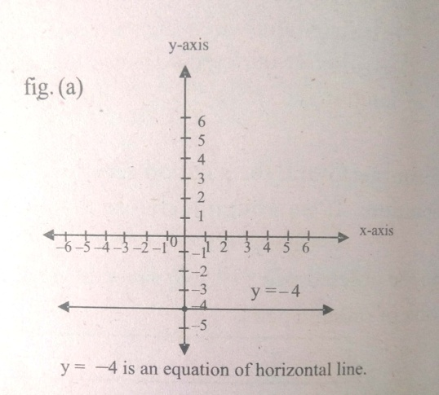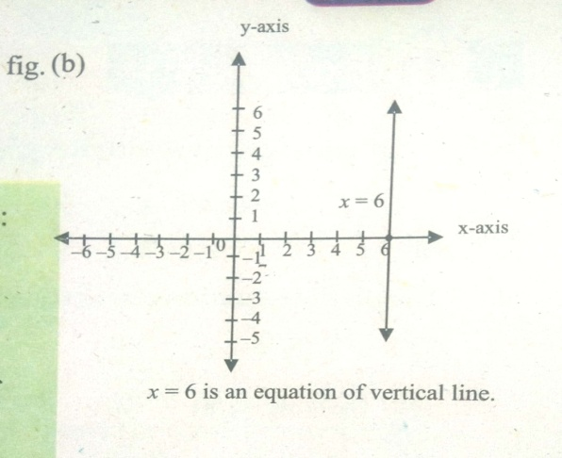

|  |  |  |
| --- | --- | --- |
| **Expected Response** | **Skill Observed** | **Score** |
| Given line is horizontal i.e. parallel to the x-axis. When, the y-coordinate is. So, the y-coordinate of every point is a constant that indicates how far above or below the x-axis, the line is drawn.  An horizontal lines has no x-intercept for  Given line is a vertical i.e. parallel to the y-axis. When, the x-coordinate is 6. So, the x-coordinate of every point is a constant that indicates how far towards the right or left of the y-axis, the line is drawn.  A vertical line has no y-intercept for. | Knowledge of the horizontal and vertical lines. | 05 Marks |

**Name and Signature of Developer**

**Zubair Mustafa**

**Reviewer Comments: ______________________________________________________________________________**

**Name and Signature of Reviewer**

**Template for Essay Type Item**

**Subject: Mathematics**

**Domain: B-Algebra**

**Grade: 7**

**Unit: 8. Linear Equations**

**Type of Assessment: Formative**

**SLO: (M-07-B-19)** Plot the graph of the linear equation  where  and of linear equations in two variables.

**Type of Task:** Constructed response

**Level of SLO:** Comprehension

**Task:** Sketch the graph of the linear equation. **(05) Marks**

**Level of Item:** Comprehension

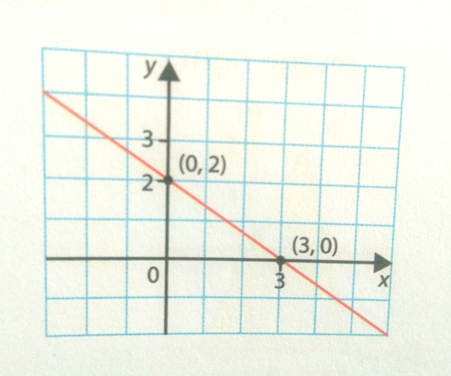

|  |  |  |
| --- | --- | --- |
| **Expected Response** | **Skill Observed** | **Score** |
| To draw a line such as , we need to know at least two points on the line. The easiest points to find are those at which the line crosses the x-axis and y-axis. On the x-axis, y=0; On the y-axis, x=0.  Take the line  When x=0, then    is one point on the line.  When y=0, then    is a second point on the line. | 1. Calculations/simplify      1. Graph | 03 Marks      02 Marks |

**Name and Signature of Developer**

**Zubair Mustafa**

**Reviewer Comments: ____________________________________________________________________________________________________________________________________________________________**

**Name and Signature of Reviewer**