**Template for Essay Type Item**

**Subject: Mathematics**

**Domain: E-Statistics and Probability**

**Grade: 7**

**Unit: 12. Data Handling**

**Type of Assessment: Formative**

**SLO: (M -07 -E -03)** i-Calculate the mean, median and mode for ungrouped data and the mean for grouped data and ii-solve related real - world problems; iii-Compare, choose and justify the appropriate measures of central tendency for a given set of data.

**Type of Task:** Constructed response

**Level of SLO:** Comprehension

**Task:** Find the arithmetic mean, median and mode from the following values. **(05) Marks**

$$5, 10, 20, 30, 10$$

**Level of Item:** Comprehension

|  |  |  |
| --- | --- | --- |
| **Expected Response** | **Skill Observed** | **Score** |
| 1. Mean 2. The median of the data is the value in the middle when the data is arranged in ascending order (For an even number of values, the median is the mean of the middle pair of values). $$5, 10, 10, 20, 30$$  Median   1. The mode of the data is the value that occurs the most often.   Mode (2 times). | 1. Formula 2. Calculation 3. Answer | 1. Marks   01 Mark  01 Mark |

**Name and Signature of Developer**

**Zubair Mustafa**

**Reviewer Comments: ____________________________________________________________________________________________________________________________________________________________**

**Name and Signature of Reviewer**

**Template for Essay Type Item**

**Subject: Mathematics**

**Domain: E-Statistics and Probability**

**Grade: 7**

**Unit: 12. Data Handling**

**Type of Assessment: Summative**

**SLO: (M -07 -E -03)** i-Calculate the mean, median and mode for ungrouped data and the mean for grouped data and ii-solve related real - world problems; iii-Compare, choose and justify the appropriate measures of central tendency for a given set of data.

**Type of Task:** Constructed response

**Level of SLO:** Comprehension

**Task:** A student obtained the following marks at a certain examination: English 73, Urdu 82, Mathematics 80, General knowledge 62. Find a) Mean b) Mode. **(05) Marks**

**Level of Item:** Comprehension

|  |  |  |
| --- | --- | --- |
| **Expected Response** | **Skill Observed** | **Score** |
| 1. Mean 2. No Mode (Not repeated any values). | 1. Formula 2. Calculation 3. Answer | 1. Marks 2. Marks 3. Mark |

**Name and Signature of Developer**

**Zubair Mustafa**

**Template for Essay Type Item**

**Subject: Mathematics**

**Domain: E-Statistics and Probability**

**Grade: 7**

**Unit: 12. Data Handling**

**Type of Assessment: Formative**

**SLO: (M-07-E-04)** Construct frequency distribution tables for given data (i.e., frequency, lower class limit, upper class limit, class interval and mid-point) and solves related real-world problems.

**Type of Task:** Constructed response

**Level of SLO:** Application

**Task:** A road-check on 30 motor vehicles yielded the following record of the number of occupants each carried:

2, 1, 3, 4, 5, 3, 2, 1, 2, 3, 1, 1, 2, 4, 6, 5, 4, 2, 2, 1, 1, 2, 4, 6, 5, 2, 6, 2, 5, 3.

Make out frequency table of the above data. **(05) Marks**

**Level of Item:** Application

|  |  |  |
| --- | --- | --- |
| **Expected Response** | **Skill Observed** | **Score** |
| |  |  | | --- | --- | | Number of occupants per vehicle | Number of vehicles **(f)** | | 1 | 6 | | 2 | 9 | | 3 | 4 | | 4 | 4 | | 5 | 4 | | 6 | 3 | | 1. Concept of Data collection 2. frequency table | 1. Marks   03 Marks |

**Name and Signature of Developer**

**Zubair Mustafa**

**Template for Essay Type Item**

**Subject: Mathematics**

**Domain: E-Statistics and Probability**

**Grade: 7**

**Unit: 12. Data Handling**

**Type of Assessment: Formative**

**SLO: (M-07-E-04)** Construct frequency distribution tables for given data (i.e., frequency, lower class limit, upper class limit, class interval and mid-point) and solves related real-world problems.

**Type of Task:** Constructed response

**Level of SLO:** Comprehension

**Task:** The heights of 100 college students measured to nearest inch are given in the following table:

|  |  |  |  |  |  |
| --- | --- | --- | --- | --- | --- |
| Height (inches) | 60-62 | 63-65 | 66-68 | 69-71 | 72-74 |
| No. of students (Frequency) | 5 | 18 | 42 | 27 | 8 |

Read the table and answer the given questions: **(03) Marks**

1. What is the frequency of the height (66-68)?
2. What is the Lower and upper limits of the height (66-68)?
3. What is the Midpoint of the height (66-68)?

**Level of Item:** Comprehension

|  |  |  |
| --- | --- | --- |
| **Expected Response** | **Skill Observed** | **Score** |
| 1. 42   The frequency of a class is the number of observations falling in that class. In the above table for (66-68), 42 is the frequency of that class.   1. Lower limit=66   Upper limit=68  Each class is defined by two values, one small and the other large. The smallest values is called lower class limit and the largest value is called upper class limit.  In the interval (66-68), 66 is called lower limit of that class and 68 is called upper limit of this class.   1. Mid point (sum of intervals and divided by 2). | 1. Application of formula in the given scenario. | 03 Marks |

**Name and Signature of Developer**

**Zubair Mustafa**

**Reviewer Comments: ______________________________________________________________________________________________________________________________________________________________________________________________________________________________________________________________________________________________________________________________________________________________________________________________________**

**Name and Signature of Reviewer**

**Template for Essay Type Item**

**Subject: Mathematics**

**Domain: E-Statistics and Probability**

**Grade: 7**

**Unit: 12. Data Handling**

**Type of Assessment: Summative**

**SLO: (M-07-E-01)** Recognize drawing and interpreting of bar graphs, line graphs and pie charts. Differentiate between a histogram and a bar graph. Construct and compare histograms for both discrete and continuous data with equal interval range. Select and justify the most appropriate graph(s) for a given data set and draw simple conclusions based on the shape of the graph.

**Type of Task:** Constructed response

**Level of SLO:** Comprehension

**Task:** Draw a histogram for the following Data. **(07) Marks**

|  |  |  |  |  |  |  |  |
| --- | --- | --- | --- | --- | --- | --- | --- |
| Class Boundary | 9.5-11.5 | 11.5-14.5 | 14.5-19.5 | 19.5-29.5 | 29.5-34.5 | 34.5-39.5 | 39.5-42.5 |
| Frequency | 4 | 12 | 25 | 60 | 25 | 15 | 6 |
| Class mark | 10.5 | 13.0 | 17.0 | 24.5 | 32.0 | 37.0 | 41.0 |
| Class interval size | 2 | 3 | 5 | 10 | 5 | 5 | 3 |
| Adjusted Frequency | 4/2=2 | 12/3=4 | 25/5=5 | 60/10=6 | 25/5=5 | 15/5=3 | 6/3=2 |

**Level of Item:** Comprehension

|  |  |  |
| --- | --- | --- |
| **Expected Response** | **Skill Observed** | **Scores** |
| Frequencies are adjusted by dividing them by the respective class interval size as shown in the following table. Figure 2.2 gives the required Histogram. | 1. Class interval size 2. Adjusted Frequency 3. Graph | 3 Marks  2 Marks  2 Marks |

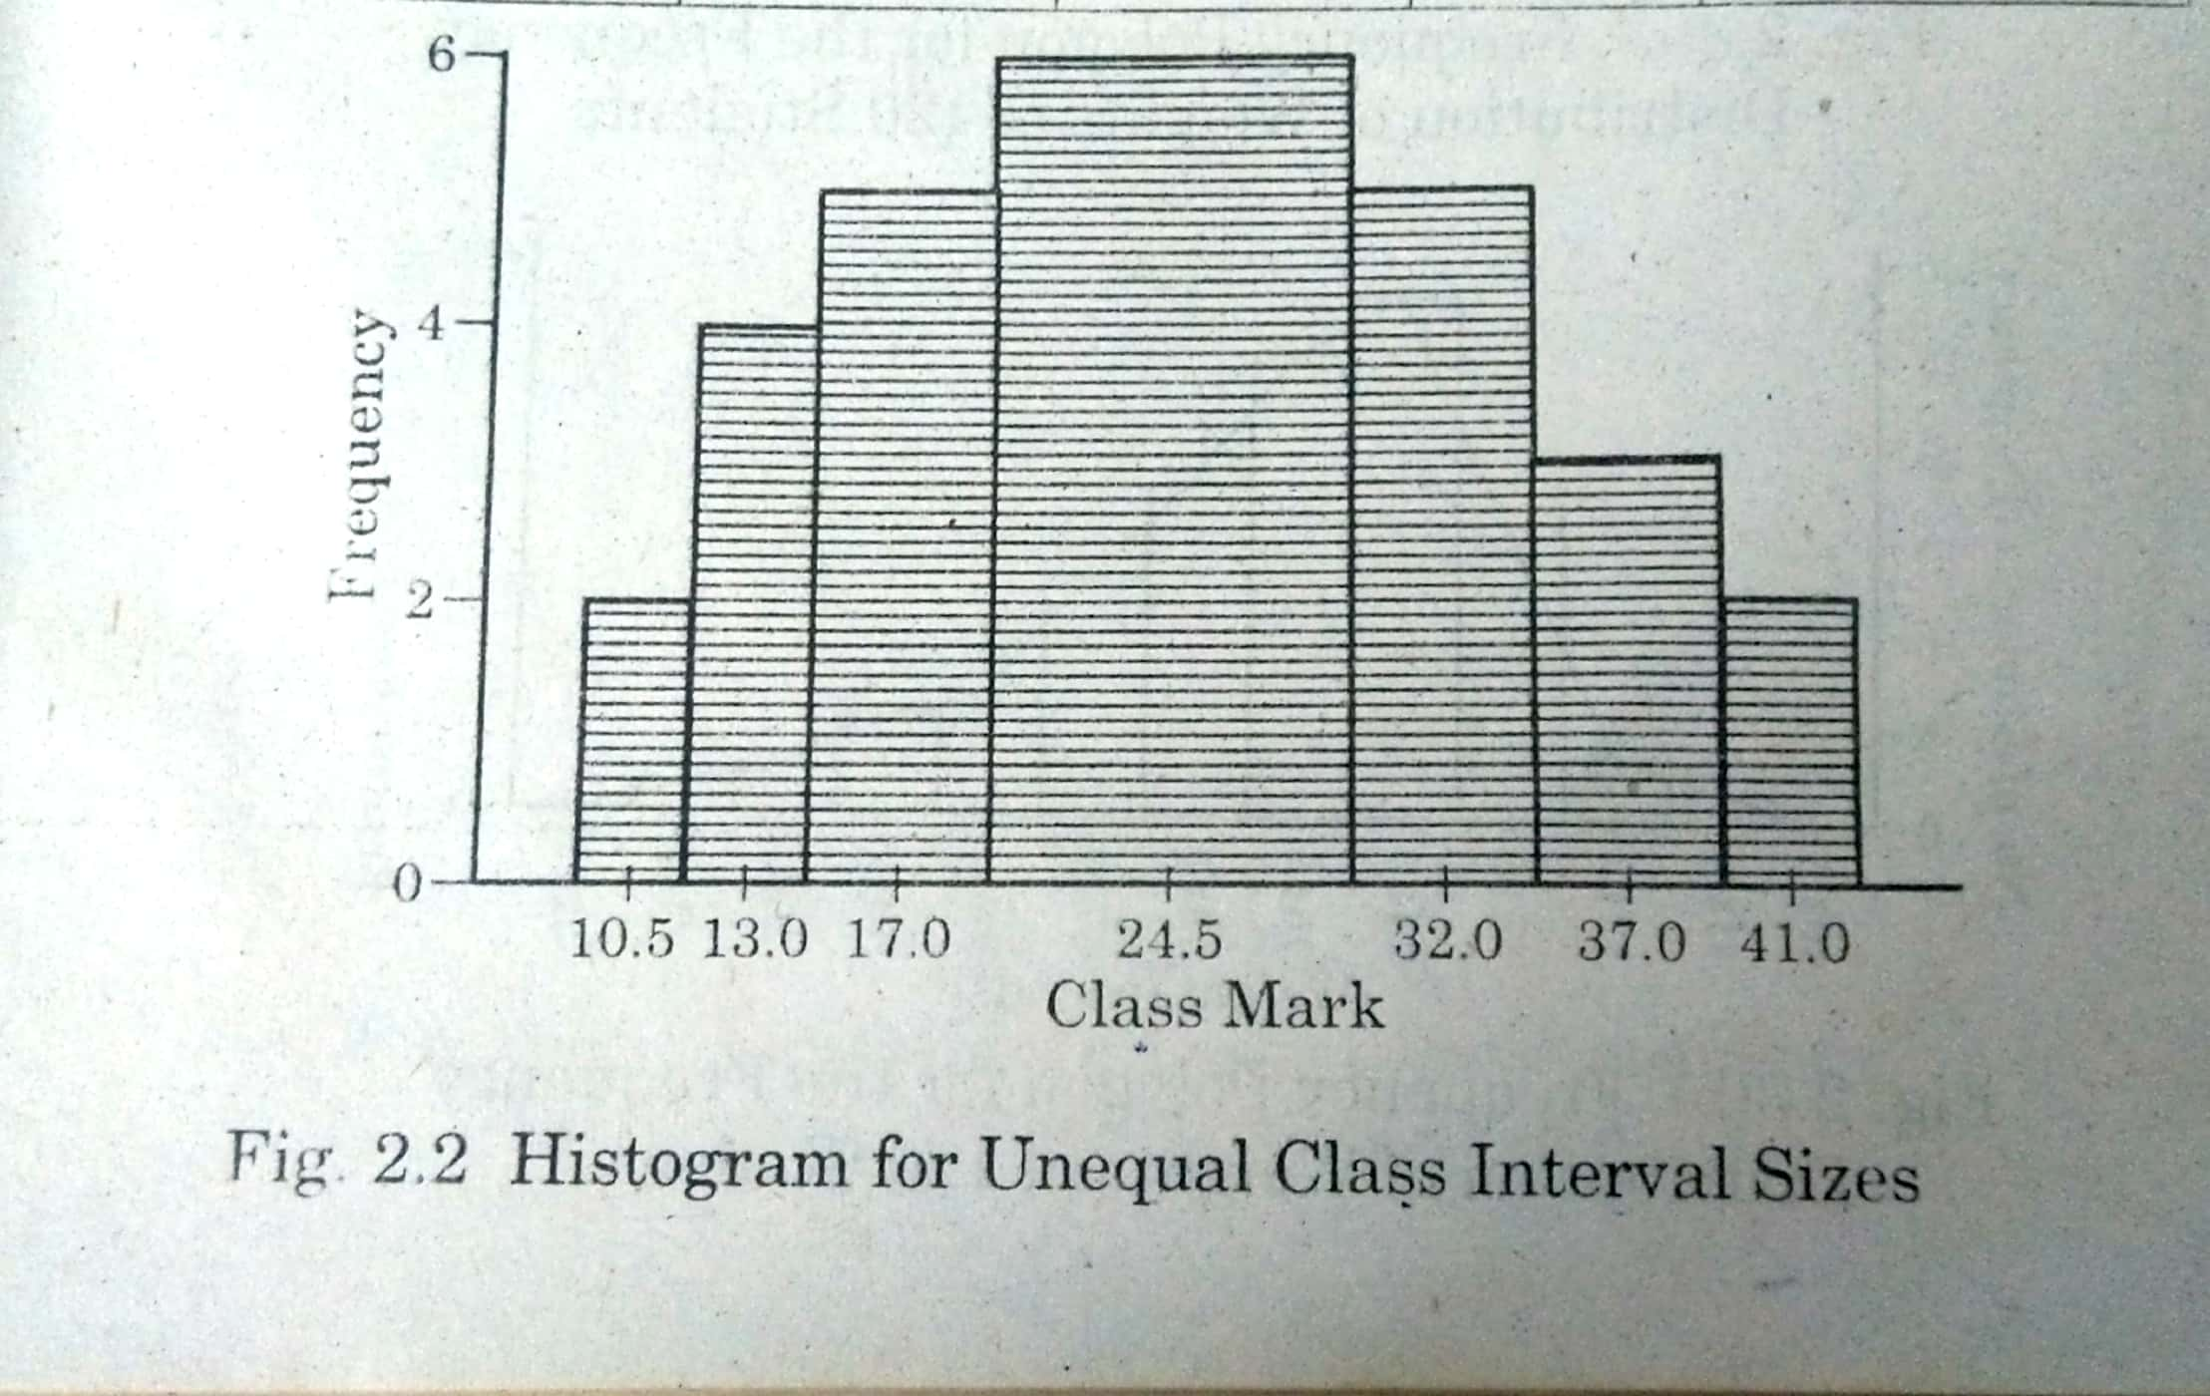

**Name and Signature of Developer**

**Zubair Mustafa**

**Reviewer Comments: ________________________________________________________________________________________________________________________________________________________________________________________________________________________________________________________________________________________________________________________**

**Name and Signature of Reviewer**

**Template for Essay Type Item**

**Subject: Mathematics**

**Domain: E-Statistics and Probability**

**Grade: 7**

**Unit: 12. Data Handling**

**Type of Assessment: Formative**

**SLO: (M -07 - E -02)** Recognize the difference between discrete, continuous, grouped and ungrouped data.

**Type of Task:** Constructed response

**Level of SLO:** Comprehension

**Task:** State whether each of the following pieces of numerical data is discrete or continuous:

1. The number of animals in the zoo
2. The score on a dice
3. Patients body temperatures
4. The number of homes in a postal district with internet access
5. The area of a football pitch. **(05) Marks**

**Level of Item:** Comprehension

|  |  |  |
| --- | --- | --- |
| **Expected Response** | **Skill Observed** | **Score** |
| 1. Discrete 2. Discrete 3. Continuous 4. Discrete 5. Continuous   **Discrete Data:**  Data which can take only certain individual values is called discrete data.  **Continuous Data:**  Continuous data is measured on some scale and can take any value on that scale. | Knowledge of the definitions. | 05 Marks |

**Name and Signature of Developer**

**Zubair Mustafa**

**Reviewer Comments: ________________________________________________________________________________________________________________________________________________________________________________________________________________________________________________________________________________________________________________________**

**Name and Signature of Reviewer**