|  |
| --- |
| COMPUTER SCIENCE |
| GRADE 7 |
| SAMPLE ITEMS |

|  |
| --- |
|  |

Grade 7 Contents

Domain A: ICT Fundamentals 2

[SLO: CS-07-A-01] 2

Formative Assessment: 2

Summative Assessment: 3

[SLO: CS-07-A-02] 4

Formative Assessment: 4

Summative Assessment: 5

Domain B: Digital Skills 6

[SLO: CS-07-B-01] 6

Formative Assessment: 6

Summative Assessment: 6

[SLO: CS-07-B-02] 8

Formative Assessment: 8

Summative Assessment: 8

Domain C: Algorithmic Thinking and Problem Solving 9

[SLO: CS-07-C-01] 9

Formative Assessment: 9

Summative Assessment: 9

[SLO: CS-07-C-02] 10

Formative Assessment: 10

Summative Assessment: 10

Domain D: Programming 11

[SLO: CS-07-D-01] 11

Formative Assessment: 11

Summative Assessment: 12

[SLO: CS-07-D-02] 13

Formative Assessment: 13

Summative Assessment: 13

Domain E: Digital Citizenship 14

[SLO: CS-07-E-01] 14

Formative Assessment: 14

Summative Assessment: 14

Domain F: Entrepreneurship in Digital Age 15

[SLO: CS-07-F-01] 15

Formative Assessment: 15

Summative Assessment: 15

**Thematic area:**

# Domain A: ICT Fundamentals

## [SLO: CS-07-A-01]

Students will be able to identify the use of emerging technologies in various walks of life (e.g., artificial intelligence, biometrics, robotics, computer-assisted translation, 3D and holographic imaging, virtual reality, Cloud Computing, and open-source software.

**Cognitive Level:**

Knowledge

### Formative Assessment:

(Marks :05)

The following worksheet comprises of pictures of different emerging technologies i.e., Artificial Intelligence, biometrics, robotics, computer assisted translation, 3D and holographic imaging, virtual reality, cloud computing, open-source software. Write down the name of respective emerging technology.

|  |  |
| --- | --- |
| Picture | Technology Name |
|  |  |
| There's a reason you should be terrified of iris scanners and iPhone facial  recognition – but it's not the reason you think | The Independent | The  Independent |  |
|  |  |
|  |  |
| Using Google Docs As an Alternative To Microsoft Office |  |

Scoring scheme:

01 mark for each correct identification

### 

### Summative Assessment:

(Marks: 05)

Name the emerging technology used in following scenarios from the given list:

(Artificial Intelligence, biometrics, robotics, computer assisted translation, 3D and holographic imaging, virtual reality, cloud computing, open-source software)

1. Playing online games
2. Detection of traffic congestion at different places
3. MRI/ ultrasound scanning for disease diagnosis
4. Handling of meeting conducted by business company that target audience who speak different languages
5. Freedom to upgrade software for your business

Scoring scheme:

01 mark for each correct identification

**Thematic area:**

**Domain A: ICT Fundamentals**

## [SLO: CS-07-A-02]

Students will be able to identify (advanced) hardware components of a computing system (e.g., different types of I/O ports, different types of peripherals, and networking components).

**Cognitive Level:**

Knowledge

### Formative Assessment:

(Marks: 15)

The following worksheet has pictures of different devices. Categorize the devices into their relevant groups by mentioning serial number and name:

1. Icon

   Description automatically generated 2. 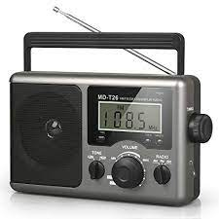 3. A black camera with a lens

   Description automatically generated with medium confidence 4. 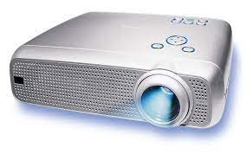

8. 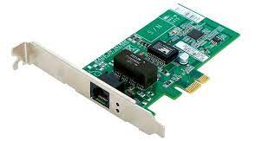

10. 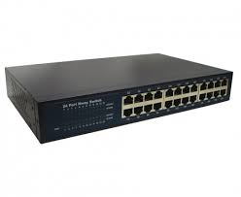

13. 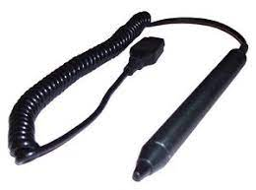 14. 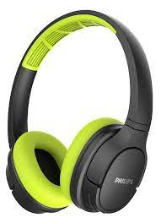 15.  16. 

|  |  |  |
| --- | --- | --- |
| Input devices | Output devices | Network devices |
|  |  |  |

Scoring scheme:

01 mark for each correct categorization of picture

### Summative Assessment:

(Marks: 08)

Label the following ports:

Scoring scheme:

01 mark for each correct labelling of picture

**Thematic area:**

# Domain B: Digital Skills

## [SLO: CS-07-B-01]

Students will be able to develop and demonstrate word-processing and presentation skills (using various software tools e.g., MS Word, MS PowerPoint, Prezi, Canva, Photo Story, Moviemaker, etc.)

**Cognitive Level:**

Application

### Formative Assessment:

(Marks: 10)

Prepare a Power Point presentation in computer lab on any topic assigned by teacher using following features:

* Includes 10-15 slides
* Different font styles
* Bullets
* Slide layout
* Background
* Transition
* Animation
* Sound effects
* Insert picture
* Slide theme

Scoring scheme:

01 mark for each correct feature

### Summative Assessment:

(Marks: 10)

Following are the two patterns of the MS-Word document, one is unformatted and other is formatted. Write down the steps to prepare the formatted document by mentioning the related features. (at least any five features)

1. Unformatted document

|  |
| --- |
| Information technology (IT)  Information technology (IT) is the use of computers, storage, networking and other physical devices, [infrastructure](https://www.techtarget.com/searchdatacenter/definition/infrastructure) and processes to create, process, store, secure and exchange all forms of electronic data. Typically, IT is used in the context of business operations, as opposed to technology used for personal or entertainment purposes. |

1. Formatted document

|  |
| --- |
| **INFORMATION TECHNOLOGY (IT)**    *Information technology* (IT) is the use of:   * computers * storage * networking * physical devices * [infrastructure](https://www.techtarget.com/searchdatacenter/definition/infrastructure) * processes   to create, process, store, secure and exchange all forms of electronic data. Typically, IT is used in the context of business operations, as opposed to technology used for personal or entertainment purposes. |

Scoring scheme:

02 marks for each correct feature

**Thematic area:**

**Domain B: Digital Skills**

## [SLO: CS-07-B-02]

Students will get introduced to electronic mailing systems (e-mail) and learn appropriate usage.

**Cognitive Level:**

Comprehension

### Formative Assessment:

(Marks: 05)

Send an email to your class teacher that requests leave for two days. Also copy email to your subject teachers. Use following features of email:

1. To
2. From
3. CC
4. Subject
5. Message

Scoring scheme:

01 mark for each correct feature

### Summative Assessment:

(Marks: 05)

Describe the following parts of an email:

1. To
2. From
3. CC
4. Subject
5. Attach file

Scoring scheme:

01 mark for each correct part

**Thematic area:**

# Domain C: Algorithmic Thinking and Problem Solving

## [SLO: CS-07-C-01]

Students will be able to apply the concept of computational thinking to handle complex problems.

**Cognitive Level:**

Application

## Formative Assessment:

(Marks: 08)

Find a solution of a problem that displays the smallest number out of three numbers by using computational thinking approach.

Scoring scheme:

02 marks for Decomposition of problem

02 marks for Abstraction of problem

02 marks for Pattern recognition of problem

02 marks for Algorithm design of problem

### Summative Assessment:

(Marks: 08)

Write down steps of computational thinking to solve the following problem:

A painter wants to determine the quantity of paint needed to paint only the walls and the interior side of the door in a room. The chosen paint covers 200 square feet per gallon. There are two windows. Use the following data to solve the problem:

* The room is 15 feet long, 12 feet wide and 10 feet tall
* The two windows are 6 by 4 feet, and 7 by 3 feet, respectively.

Scoring scheme:

02 marks for Decomposition of problem

02 marks for Abstraction of problem

02 marks for Pattern recognition of problem

02 marks for Algorithm design of problem

**Thematic area:**

**Domain C: Algorithmic Thinking and Problem Solving**

## [SLO: CS-07-C-02]

Students will be able to apply concepts of conditional statements, finite and infinite loops to write different algorithms.

**Cognitive Level:**

Application

### Formative Assessment:

(Marks: 08)

Write down an algorithm that displays the sum of first hundred even numbers.

Scoring scheme:

03 marks for correct use of sequence of steps

03 marks for correct use of input/output

04 marks for correct use of controls

### Summative Assessment:

(Marks: 10)

Write down an algorithm that takes an integer number and prints its table by using loop. the algorithm will terminate if input number is zero (0).

Scoring scheme:

03 marks for correct use of sequence of steps

03 marks for correct use of input/output

04 marks for correct use of controls

**Thematic area:**

# Domain D: Programming

## [SLO: CS-07-D-01]

Students will be able to explain how computers encode and decode computer programs (i.e. identification of decimal to binary and vice versa, conversion of texts, images and sounds in binary).

**Cognitive Level:**

Comprehension

### Formative Assessment:

(Marks: 10)

Complete the following worksheet:

* that convert a binary number into decimal number system

|  |
| --- |
|  |

* that convert a decimal number into binary number system

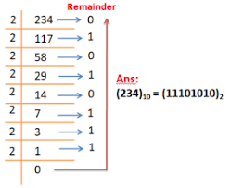

Scoring scheme:

01 mark for each box

### Summative Assessment:

(Marks: 12)

Convert the following into respective number system:

1. ( 10111101 )2  🡪 ( ? )10
2. ( 00001 )2  🡪 ( ? )10
3. ( 96000 )10  🡪 ( ? )2
4. ( 23456 )10  🡪 ( ? )2

Scoring scheme:

03 marks for each part with complete steps

**Thematic area:**

**Domain D: Programming**

## [SLO: CS-07-D-02]

Students will be able to apply fundamental programming constructs to create multi-sprite, multi-script programs using visual programming tools.

**Cognitive Level:**

Application

### Formative Assessment:

(Marks: 10)

Develop a ‘Jumping Chick and Egg’ game using visual programming tools that creates and move characters.

Scoring scheme:

03 marks for correct use of sequence of steps

03 marks for creation/ movement of characters

04 marks for correct use of controls

### Summative Assessment:

(Marks: 10)

Write a program using visual programming tools to show the dialogue between two friends on the topic of ‘ Ethics ’.

Scoring scheme:

03 marks for correct use of sequence of steps

03 marks for creation/ movement of characters

04 marks for correct use of controls

**Thematic area:**

# Domain E: Digital Citizenship

## [SLO: CS-07-E-01]

Students will identify ways to protect against malicious activities or behaviors in the digital environment.

**Cognitive Level:**

Knowledge

### Formative Assessment:

(Marks: 05)

Write down any five preventive measures from malicious attacks.

Scoring scheme:

01 mark for each measure

### Summative Assessment:

(Marks: 03)

What is malicious software? List any four malicious software.

Scoring scheme:

01 mark for definition

02 marks for correct names

**Thematic area:**

# Domain F: Entrepreneurship in Digital Age

## [SLO: CS-07-F-01]

Students will analyze the uses and benefits of design thinking for entrepreneurs.

**Cognitive Level:**

Application

### Formative Assessment:

(Marks: 10)

An educational entrepreneur needs to develop classroom seating plan to conduct midterm examination of two different grades i.e., grade 6 and grade 7 in one room. Seating plan should accommodate approximately fifty (50) students in such a way that no two consecutive students are of same grade.

Instructions:

Draw a seating plan on paper by labelling the steps of design thinking process.

Scoring scheme:

02 mark for each step

### Summative Assessment:

(Marks: 05)

Analyze the steps of design thinking process with the help of example.

Scoring scheme:

02 marks for each step