DRAFT

Mathematics - Class 6
Suggested Guidelines
DOMAIN: Numbers and Operations
Sub-Domain: Multiples and Factors
STEP 1 _________________________________________________________
Standard : Students will be able to recognize factors, multiples, HCF and LCM
Student Learning Outcomes: Students will be able to
- Recognize factors of numbers up to 3-digit
- Multiples of numbers up 2-digit.
- HCF and LCM.
Knowledge:  Students will be able to know:  - Factors of numbers up to 3-digit  - Multiples of numbers up to 2-digit  - Highest Common Factor (HCF)  - Least Common Multiple (LCM) | Skills:  Students will  - Find factors of up to 3-digit numbers  - Find multiples of up to 2-digit numbers  - Find prime factors of a given number up to 4-digit express its factors in the index notation (base and exponent)  - Find HCF of three numbers upto3-digits by  - prime factorization  - division method  - Find LCM of up to four numbers of 3-digits by  - prime factorization  - division method  - Apply HCF and LCM in real life situations  - Recognize and calculate squares of up to 2-digit numbers.  Additional/Advanced:  Students will be able to:  - Find relation between HCF and LCM
STEP 2 _________________________________________________________
Assessments:
Formative Assessments:
Some of the types of formative assessment teacher may use are:
- Question & Answer(open and closed)
- Quick Quiz
- Learning Walks
- Projects,
- Selected responses (may include MCQs, true: false, matching short answers, fill-in-the blanks, etc),
- Observation diaries
- Inquiry charts,
- Four Corners: Gather students in the middle of the room, and read multiple-choice questions and their possible answers aloud. Students then move to the corner that represents what they believe is the correct answer. The top left room corner can be option A, the bottom-left can be B and so on.
Summative Assessments
Some of the forms of summative assessment are:
- End of Unit Test
- Class Test
- Periodic/Monthly Tests
- Mid-year Exam
- End of Year Exam
- Standardized tests.
- External Exams

Some of the sample questions that can be used as part of formative assessment are:
- Write any 3-digit number and do prime factorization. Peer checking can be done for this task.
- Write first five multiples of numbers 10– 15 in 2 minutes.
- Find the lowest number which is exactly divisible by 18 and 24.
- Find the greatest number that divides 90 and 126 exactly.
Some of the sample questions that can be used as part of summative assessments are:
- Write the multiples of 6 which are greater than 20 and less than 50.
- Write all the prime numbers between 1 and 15.
- Write all the composite numbers between 1 and 30.
- Write all the prime numbers between the following:
- and 50 50 and 90 61 and 80
- Write all the composite numbers between the following:
40 and 50 75 and 90 25 and 35
- Find the highest common factor of the given numbers by long division method.
- and 30 75 and 180
- Two ropes are 64 cm and 80 cm long. What maximum length of pieces can be cut equally from the given ropes?
- A shopkeeper sells candles in packets of 12 and candle stands in packet of 8. What is the least number of candles and candle stands Nita should buy so that there will be one candle for each candle stand.
- A florist wants to arrange 24 bouquets of flowers in different rows. Find out in how many ways he can arrange the bouquets with same number in each row.

STEP 3 _ ________________________________________________________
Learning Activities
- Teacher can explain the concept of factors by making a combination table.
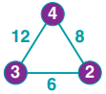
- Teachers can also use a puzzle of different polygons to make learning fun. For example in the following polygon, the number beside each line segment is the product of the factors in the circles at each end of the line segment.
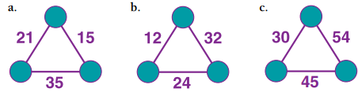
- Teachers can ask students to make different polygons and exchange with other classmates as a challenge.
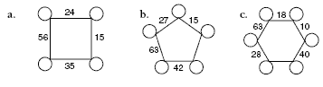
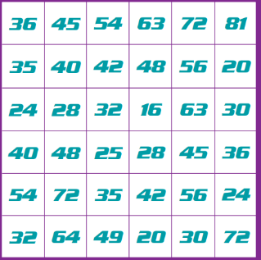
- Teachers can play a bingo game with 2 dice and provide students with a number grid. 1-dice will be used with original numbers i.e. 1-6 and others will be used as 4-9. This game will be played in pairs:
    - Take turns to roll the dice.
    - On your turn, multiply the two numbers showing on the dice and mark square on the board that shows the product.
    - The first player to cover three squares in a row (vertically, horizontally, or diagonally) wins.
    - If neither player ends up with three counters next to each other, the game is a draw.
- Teachers can use an interesting activity for introducing factorization by continuing the roots to their prime factors. On a sheet of brown construction paper, have students draw a tree trunk. On the trunk write the number 24. Below the trunk, have students draw roots with all the possible factors of 24: 1, 2, 3, 4, 6, 8, 12 and 24. Have students complete this activity with other numbers.
- Teachers can play Two –Minute Multiple games with students by asking students to write numbers 2 - 10 in a column on their mini white boards. Teacher will set the timer of 2 minutes and will read aloud the first 10 multiples of 2 - 10. Students will be required to write the multiple corresponding to the correct number. When time is up, each player counts the multiples written next to the numbers. The player with the most correct multiples wins!
- Teacher can use following activity to do practice of prime factorization:
- Ask students to stand in an open space at least an arms-length away from each other.
- Tell them that you will be calling out numbers (such as 13, 21 or 101) and they will need to decide if the number is prime or composite.
- If prime, they should sit down. If composite, they should stand up.
- After calling out a composite number, choose a standing student to give the prime factorization of the number
- Teacher can share following online game with students to practice prime factorization
https://www.mathplayground.com/factortrees.html
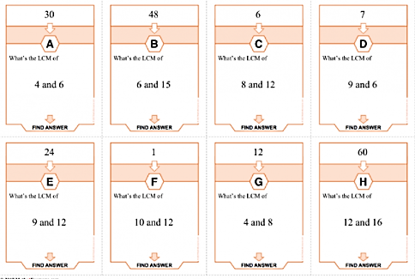
- Teachers can make cards to play treasure hunt with students. Each card will contain the answer of any other card and a question. Students will solve the questions to solve the treasure hunt.
Figure 1 [Treasure Hunt Cards] [tes]

- Teacher can share following online game with students to practice Highest Common Factor (HCF) and Least Common Multiple (LCM)
https://www.transum.org/software/SW/Starter_of_the_day/Students/HCF_LCM.asp
https://www.transum.org/software/SW/Starter_of_the_day/Students/HCF_LCM.asp?Level=2

- Following coloring activity sheet can be provided to students to match the square numbers by coloring the block with same color.
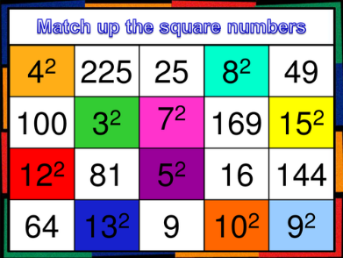
Figure 2 [Square Numbers] [tes]
- Following type of maze game can be used as a fun learning activity by teachers to practice square numbers.
Figure SEQ Figure \* ARABIC 3 [Square Numbers] [teacherspayteachers]

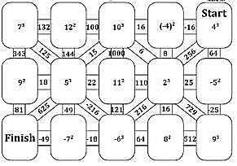

Figure 3 [Square Numbers] [tes]

Reference:
TES (2021) Retrieved from: https://www.tes.com/teaching-resource/lcm-and-hcf-treasure-hunt-11743277

TES (2021) Retrieved from:
https://www.tes.com/teaching-resource/square-numbers-matchup-game-11059444

Teachers Pay Teachers (2021) Retrieved from: https://www.teacherspayteachers.com/Product/Squared-and-Cubed-Numbers-Maze-4790446

Domain: Number and Operations
Sub-Domain: Integers
STEP 1 _________________________________________________________
Standard: Students will be to recognize and identify integers, their absolute values and compare and arrange in different order.
Student Learning Outcomes: Students will be able to
- Recognize and identify integers (positive integers, negative integers and neutral integers).
- Calculate absolute or numerical value of an integer.
- Using a number line,compare and arrange a given list of integers and their absolute values in ascending and descending order
Knowledge:  Students will be able to know:  - Integers  - Negative integers  - Positive integers  - Zero (0) as a neutral integer  - Absolute or numerical value of an integer  - Integers on number line | Skills:  Students will  - Represent integers on number line  - Identify integers on number line as:  - positive integer  - negative integer  - neutral integer  - Arrange a given list of integers in ascending and descending order  - Arrange the absolute or numerical values of the given integers in ascending and descending order  - Apply integers to solve real life situations
STEP 2 _________________________________________________________
Assessments:
Formative Assessments.
Some of the types of formative assessment teacher may use are:
- Question & Answer(open and closed)
- Quick Quiz
- Learning Walks
- Projects,
- Selected responses (may include MCQs, true: false, matching short answers, fill-in-the blanks, etc),
- Observation diaries
- Inquiry charts,
- Four Corners: Gather students in the middle of the room, and read multiple-choice questions and their possible answers aloud. Students then move to the corner that represents what they believe is the correct answer. The top left room corner can be option A, the bottom-left can be B and so on.
Summative Assessments
Some of the forms of summative assessment are:
- End of Unit Test
- Class Test
- Periodic/Monthly Tests
- Mid-year Exam
- End of Year Exam
- Standardized tests.
- External Exams
Some of the sample questions that can be sued as part of the formative assessment are:
Ask students the following type of questions:
- Note down temperatures of their five favorite countries and represent them on the number line.
- Write any five negative numbers and any 5 positive numbers and find their absolute values.
- Students can be asked a riddle: A special integer exists in mathematics that shows a special property. If you subtract any number from that integer, the result will always be divisible by the successor of that number completely.

Some of the sample questions that can be used as part of the summative assessments are:
Ask students the following type of questions:
- In each case, arrange the given integers in ascending order:
-8, 0, -5, 5, 4, -1
3, -3, 4, -7, 0, -6, 2
-1, -7, 8, -3, 0, 3, 17
- In each case, arrange the given integers in descending order:
-5, -3, 8, 15, 0, -2
12, 23, -11, 0, 7, 6
-1, -21, -31, 12, 5, 11
- Find the mod of:
|14 - 6| = |8| = 8 - |- 10| = - 10 15 - |- 6| = 15 - 6 = 9
7 + |- 7| = 7 + 7 = 14
- When Steve woke up. His temperature was 102º F. Two hours later it was 3º lower. What was his temperature then?
- An elevator is on the twentieth floor. It goes down 11 floors and then up 5 floors. What floor is the elevator on now?
- Josie has $47 left on her checking account. If she writes a check for $55, what will Josie’s balance be?
- It will be – 12º tonight. The weatherman predicts it will be 25º warmer by noon tomorrow. What will the temperature be by noon tomorrow?
- The elevation of Mt. Everest is 29,028 feet. The elevation of the Dead Sea is –485 feet. What is the difference in the elevation between Mt. Everest and the Dead Sea?
STEP 3 _ ________________________________________________________
Learning Activities
- Teacher will ask students to give real life scenarios where they have seen negative numbers.
- Teacher can show the following video to discuss real life examples of integers.
https://www.youtube.com/watch?v=9w7gwFA1HNI
- Number cards will be made by teacher and students will be asked to add negative or positive signs and then arrange them in ascending or descending order.
- Different temperature cards will be displayed to students and they will be asked to arrange them in order from coldest to warmest.
- Number line will be displayed on board and students will be asked to point out the position of different integers on number line.
- Teacher can prepare a short worksheet of filling the missing spaces on number line.
- Students can play a game with dice in pairs to compare integers.
- Teacher will provide a handout with some blank spaces for 2-digit or 3-digit numbers with positive and negative signs and an empty box in between number blanks for comparison of integers.
- Player 1 will role dice and fill one blank of question and then player 2 will role dice and fill the other blank then according to positive and negative signs, players will determine which sign goes between numbers(< , > or =).
- The player with greater number gets 1 point.
- Following Online game link can be shared with students for practice of arranging integers.
https://www.mathplayground.com/mobile/numberballs_fullscreen.htm
- Teacher can show the following video to explain concept of absolute value. Video can be paused at several intervals to ask questions from students.
https://www.youtube.com/watch?v=zxaT8ArCKjQ
- Following Online game link can be shared with students for practice of finding absolute value of integer.
https://www.math-play.com/Millionaire-Game-Absolute-Value/Millionaire-Game-Absolute-Value_html5.html

Domain: Number and Operations
Sub-Domain: Laws of Integers

STEP 1 _________________________________________________________
Standard: Students will be able to apply four operations (+, - , x, ÷ BODMAS), commutative, associative and distributive laws on integers.
Student Learning Outcomes: Students will be able to
- Add upto-2-digit like and unlike integers.
- Verify commutative and associative laws.
- Subtract up to 2-digit like and unlike integers.
- Multiply up to 2-digit like and unlike integers.
- Verify commutative, associative and distributive laws.
- Divide like and unlike integers up to 2-digit.
Knowledge:  Students will be able to know:  - Commutative, associative and distributive laws.  - “0”as an additive identity  - Additive inverse of an integer  - “1”as a multiplicative identity  - Order of mathematical operations by applying the BODMAS rule. | Skills:  Students will  - Add two integers up to 2-digit with the same and opposite signs and represent it on a number line  - Verify commutative and associative law of addition for integers up to 2-digit numbers  - Subtract two integers up to 2-digit with same and opposite signs.  - Multiply two integers up to 2-digit with the same and opposite signs  - Verify commutative and associative law of multiplication for integers up to 2-digit numbers  - Verify Distributive law of multiplication over addition up to 2-digit integers  - Verify Distributive law of multiplication over subtraction up to 2-digit integers  - Divide Two Integers With Same And Opposite Signs.  - Explain the order of mathematical operations by applying the BODMAS rule.  - Simplify Mathematical Expressions Involving integers, fractions and decimals.
STEP 2 _________________________________________________________
Assessments:
Some of the types of formative assessment teacher may use are:
- Question & Answer(open and closed)
- Quick Quiz
- Learning Walks
- Projects,
- Selected responses (may include MCQs, true: false, matching short answers, fill-in-the blanks, etc),
- Observation diaries
- Inquiry charts,
- Four Corners: Gather students in the middle of the room, and read multiple-choice questions and their possible answers aloud. Students then move to the corner that represents what they believe is the correct answer. The top left room corner can be option A, the bottom-left can be B and so on.
Summative Assessments
Some of the forms of summative assessment are:
- End of Unit Test
- Class Test
- Periodic/Monthly Tests
- Mid-year Exam
- End of Year Exam
- Standardized tests.
- External Exams

Some of the sample questions that can be used as part of formative assessments are:
Ask students the following type of questions:
- Make a poster of Addition and subtraction rules of integers with examples.
- Make mathematical expressions and exchange it with other students to take it as a challenging question.
- Maze hand out can be given to students to assess mathematical expressions.

Some of the sample assessments that can be used as part of the summative assessments are:
Ask students the following type of questions:
- Simplify :
12-[20÷{8-2(9-5-2)}]
25− [4 + {16 − (12 − 2)}]
36 − [18 − {14 − (15 − 4 ÷2 ×2)}]
13-[20 ÷{8-2(9-5-2)}]

- Challenge Activity for students
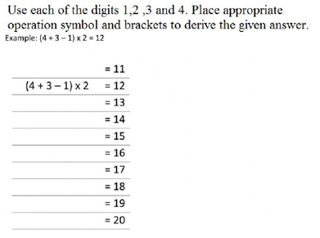
Figure 4 [Challenge Activity] [liveworksheets]
STEP 3 _ ________________________________________________________
Learning Activities
      - Teachers can use the following links to explain the concept of adding and subtracting integers.
https://www.youtube.com/watch?v=CfkaifC7tGY
https://www.youtube.com/watch?v=1DKWG5CBeek
      - Teachers can use playing cards to practice adding, subtracting and multiplying integers.
  - Red cards are negative and black cards are positive
  - Deck will be placed in the center of the table upside down and each student will be asked to take out 2 cards.
  - Students will be asked to add, subtract or multiply the value of their card
  - To get a 2-digit number students will take out 2 cards to create 1 value.
  - On giving each right answer, Students will get 1 point.
- Following Online game link can be shared with students for practice of adding integers.
https://www.mathplayground.com/ASB_SpiderMatchIntegers.html
- Teachers can explain the commutative property by following activity.
- Write this problem on the board. For example, 9 + 2 = ___
- Have nine children stand to the left of the board and two children to the right. Have the children count all the students for the answer of 11.
- Shift, write 2 + 9 = on the board and discuss that it doesn't matter in addition, the ORDER of the problem, just the total amount of items, the sum.
- KEEP the same students in the two groups but have them shift to the left or right so the nine students are now on the right and the SAME two students are on the left.
- Discuss how the total number of students have not changed, and that we call this the Commutative Property of Addition.
- Teachers can use 3 dice to practice associative property. Teacher will provide a handout of associative property with blanks. Students will roll all 3 dice at once and will write the numbers in the same sequence on both sides and then they will solve both sides to find out both sides give the same answer.
- Teachers can explain the concept of distributive property by using a real-life scenario. For example,
- Imagine one student and her two friends each have seven strawberries and four apples. How many pieces of fruit do all three students have in total?
- In their lunch bags — or, the parentheses — they each have 7 strawberries and 4 apples. To know the total number of pieces of fruit, they need to multiply the whole thing by 3.
- When you break it down, you’re multiplying 7 strawberries and 4 apples by 3 students. So, you end up with 21 strawberries and 12 apples, for a total of 33 pieces of fruit.
- Following Online game links can be shared with students for practice of Commutative, Associative and Distributive property.
https://www.mathgames.com/skill/3.37-properties-of-addition
https://www.mathgames.com/skill/3.38-solve-using-properties-of-addition
https://www.mathgames.com/skill/7.96-properties-of-addition-and-multiplication
- Teacher can make a concept map of BODMAS on board to explain the order of operations.
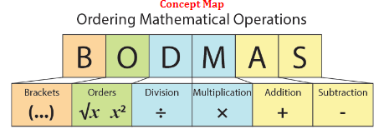
Figure 5 [BODMAS CONCEPT RULE] [liveworksheets]
- Teachers can take a box in class containing mathematical expressions written on folded paper chits. Students will be asked to take out one paper chit and solve it. First student solving the mathematical expression correctly will be announced “Math Genius” of class.
Reference:
Liveworkseets (2021) Retrieved from:
https://www.liveworksheets.com/bp935523uz

Domain: Number and Operations
Sub-Domain: Rate, Ratio and Percentage

STEP 1 _________________________________________________________
Standard: Students will be able to define and calculate ratio, rate, and percentage and apply these in real life context.
Student Learning Outcomes: Students will be able to
- Define and calculate ratio, equivalent ratio, rate and percentage.
- Solve real life problems involving ratio, rate and percentage.
Knowledge:  Students will be able to know:  - Ratio, equivalent ratio, rate.  - Difference between ratio and rate.  - Ratio has no unit but the rate has a unit.  - Meaning of percentage.  - The amount, the base, and the percent in a percent problem.  Additional:  Students will be able to know relation between distance, time and speed | Skills:  Students will  - Express ratio as comparison of two quantities that are measured in same units  - Calculate ratio of two numbers/ quantities up to3-digit  - Simplify given ratio into lowest(equivalent)form  - Describe the relationship between ratio and fraction  - Explain continued ratio.  - Explain rate as comparison of two quantities that are measured in different units.  - Express one quantity as percentage of another  - Compare two quantities by percentage  - Increase or decrease a quantity by a given percentage  - Solve Real Life Situations involving percentage  - Solve Real Life Situations Involving Ratio, Rate and Percentage.  Additional:  Students will be able to:  - convert 12-hr clock time to 24-hr clock time (calculating journey time)  - solve real-life problems involving distance, time and speed
STEP 2 _________________________________________________________
Assessments:
Some of the types of formative assessment teacher may use are:
- Question & Answer(open and closed)
- Quick Quiz
- Learning Walks
- Projects,
- Selected responses (may include MCQs, true: false, matching short answers, fill-in-the blanks, etc),
- Observation diaries
- Inquiry charts,
- Four Corners: Gather students in the middle of the room, and read multiple-choice questions and their possible answers aloud. Students then move to the corner that represents what they believe is the correct answer. The top left room corner can be option A, the bottom-left can be B and so on.
Summative Assessments
Some of the forms of summative assessment are:
- End of Unit Test
- Class Test
- Periodic/Monthly Tests
- Mid-year Exam
- End of Year Exam
- Standardized tests.
- External Exams

Some sample questions that can be used as part of formative assessments are:
Ask students the following type of questions:
- Use their favorite recipe and find out the quantity of each ingredient to make 15 servings.
- Make a discount poster of their favorite clothing shop. And make a list of 5 articles with original price and 25% discounted price.

Some sample questions that can be used as part of summative assessments are:
Ask students the following type of questions:
- The length of the ribbon was originally 30 cm. It was reduced in the ratio 5: 3. What is its length now?
- Mother divided the money among Ron, Sam and Maria in the ratio 2: 3: 5. If Maria got $150, find the total amount and the money received by Ron and Sam.
- The ratio of the number of boys and girls is 4:3. If there are 18 girls in a class, find the number of boys in the class and the total number of students in the class.
- Jason is driving across the country. For the first 3 hours, he travels 60 mph. For the next 2 hours he travels 72 mph. Assuming that he has not stopped, what is his average traveling speed in miles per hour?
- Tom runs a 100m race in a certain amount of time. If John runs the same race, he takes 2 seconds longer. If John ran at 8m/s, approximately how fast did Tom run?
- In an election, candidate A got 75% of the total valid votes. If 15% of the total votes were declared invalid and the total number of votes is 560000, find the number of valid votes polled in favor of the candidate.
- A shopkeeper bought 600 oranges and 400 bananas. He found 15% of oranges and 8% of bananas were rotten. Find the percentage of fruits in good condition.
- Aaron had $ 2100 left after spending 30 % of the money he took for shopping. How much money did he take along with him?
STEP 3 ________________________________________ _______
Learning Activities
      - Teachers can demonstrate the concept of ratio by M&M Activity. Each student will get a pack of M&Ms of assorted colors. Teacher will lead students through how they will fill out the activity sheet. Students will count the total M&Ms and will calculate the ratio of each color to total M&Ms.
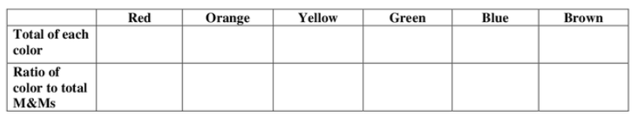
      - Teacher can explain the concept of equivalent ratios by using kid’s favourite recipe to make several servings.
      - Following Online game links can be shared with students for practice of unit rate:
https://www.brainpop.com/games/unitrates/?topic_id=
      - Teacher can Challenge students to use their knowledge about percentages in this fun game. Just roll the dice and race to calculate the percentage. Whoever gives the correct answer first earns a point and the first person to reach 15 points wins!!
- In order to determine the percentage, students will pick a card from the deck and whatever number they’ll draw they will have to add zero at its end. For example, if student draws an 8 the percentage need to calculate will be 80
- 2 dice will be rolled to get a number of which percentage has to be calculated.
- The first player should turn over a card and roll the dice.
- Players race to see who can get the correct percentage of the number rolled on the dice. For example, if the total of the 2 dice was 11 and the percent was 20%, players try to determine what 20% of 11 is. 4. The first player to get the correct answer wins that round and gets a point. Play continues until one player reaches 15 points.
      - Following Online game links can be shared with students for practice of percentage increase or decrease.
https://www.quia.com/rr/230204.html

Domain: Number and Operation
Sub-Domain: Sets

STEP 1 _________________________________________________________
Standard: Students will be able to use language notation and Venn diagrams to represent sets.
Student Learning Outcomes: Students will be able to
- Use language, notation and Venn diagrams to represent different types of sets and their elements ( empty, singleton , subsets , proper, improper subsets and universal set , finite and infinite sets).
Knowledge:  Students will be able to know:  - Set, an element of a set, empty set.  - Singleton set and universal set.  - Types of sets.  - Sets using Venn diagrams.  Additional:  Students will be able to know about subsets of a given set | Skills:  Students will be able to  - Name the sets using capital letters A, B, C etc. And use symbol for empty set (Փ).  - Differentiate between elements of a set, finite & infinite sets and universal sets.  - Identify and find the subsets (proper and improper) of a set, finite and infinite sets.  - represent sets using Venn diagrams
STEP 2 _________________________________________________________
Assessments:
Some of the types of formative assessment teacher may use are:
- Question & Answer(open and closed)
- Quick Quiz
- Learning Walks
- Projects,
- Selected responses (may include MCQs, true: false, matching short answers, fill-in-the blanks, etc),
- Observation diaries
- Inquiry charts,
- Four Corners: Gather students in the middle of the room, and read multiple-choice questions and their possible answers aloud. Students then move to the corner that represents what they believe is the correct answer. The top left room corner can be option A, the bottom-left can be B and so on.
Summative Assessments
Some of the forms of summative assessment are:
- End of Unit Test
- Class Test
- Periodic/Monthly Tests
- Mid-year Exam
- End of Year Exam
- Standardized tests.
- External Exams

Some of the sample questions that can be used as part of formative assessments are:
Ask students the following type of questions:
- Make sets of first ten multiples of 6 and 8 and find union and intersection of sets using Venn diagram.
- Students can be asked to do a short activity in pairs. In each pair, students will make a set of his/her favorite food items, after making a set, each pair of students will find the union and intersection of their favorite colors.
Summative Assessments
Ask students the following type of questions:
- If A = {1, 3, 7, 9, 10}, B = {2, 5, 7, 8, 9, 10}, C = {0, 1, 3, 10}, D = {2, 4, 6, 8, 10}, E = {negative natural numbers} and F = {0}
Find:
(i) A ∪ B (ii) E ∪ D (iii) C ∪ F (iv) C ∪ D (v) B ∪ F (vi) A ∩ B
(vii) C ∩ D (viii) E ∩ D
- If P = {multiples of 3 between 1 and 20} and Q = {even natural numbers upto 15}. Find the intersection of the two given sets P and set Q.
STEP 3 _ ________________________________________________________
Learning Activities:
            - Teachers can use the following online game link for practice of symbols used in set.
https://www.transum.org/software/SW/Starter_of_the_day/Students/Set_Notation/Default.asp
            - Teachers can use the following online video link to explain types of sets.
https://www.youtube.com/watch?v=8dup8yGwBhM

Teacher can explain the concept of representing sets using the Venn diagram by the following activity: Teacher will make three sets of hobbies. Sports, Reading and Computer games.
- Set A is for pupils who like sport.
- Set B is the pupils who like reading.
- Set C is for pupils who like computer games.
- Teacher will write the names of students in each set. And then construct the Venn diagram on board.
            - Teacher can use following online video link to explain union and intersection of two set
https://www.youtube.com/watch?v=YEsBbAGqkZw
            - Teacher can use following activity to do practice of set:
- These activities will require students to be grouped prior to the beginning of the activity.
- Divide students into groups of 5-7
- Give one set of numbers to each group
- Teacher will write a few sets on the b board. A - D
- Call out a problem such as ''The union of A and E''.
- The first group to raise the correct number cards reflecting the answer to your question gets a point.
- Continue for as long as desired. The team with the most points at the end of the game wins
      - Teachers can use the following online puzzle link for practice of Venn diagram used in set.
https://www.univie.ac.at/future.media/moe/tests/mengen/duv.html

DOMAIN: Algebra
Sub-Domain: Algebraic Expression

STEP 1 _________________________________________________________
Standard: Students will be able to recognize simple number patterns, use letters to represent numbers, evaluate, add, subtract and simplify linear expressions.
Student Learning Outcomes: Students will be able to
- Recognize simple patterns from various number sequences.
- Use letters to represent numbers, express basic arithmetical processes algebraically.
- Evaluate algebraic expressions, add and subtract linear expressions.
- Simplify linear expressions.
- fhgdfjkhgjhgk
Knowledge:  Students will be able to know:  - Simple patterns from various number sequences.  - Term Algebra as an extension of arithmetic, where letters, numbers and symbols are used for construction of algebraic expressions  - Basic arithmetic operation using Algebra  - Algebraic sentence as combination of algebraic expressions using symbols =,  - ≠. | Skills:  Students will  - Continue a given number sequence and find a term to term rule.  - Solve real life problems involving number sequences and patterns  - Evaluate an algebraic expression or algebraic formula  - Differentiate a statement as open, true and false  - Manipulate simple algebraic expressions using addition and subtraction  - Simplify Algebraic Expressions
STEP 2 _________________________________________________________
Assessments:
Some of the types of formative assessment teacher may use are:
- Question & Answer(open and closed)
- Quick Quiz
- Learning Walks
- Projects,
- Selected responses (may include MCQs, true: false, matching short answers, fill-in-the blanks, etc),
- Observation diaries
- Inquiry charts,
- Four Corners: Gather students in the middle of the room, and read multiple-choice questions and their possible answers aloud. Students then move to the corner that represents what they believe is the correct answer. The top left room corner can be option A, the bottom-left can be B and so on.
Summative Assessments
Some of the forms of summative assessment are:
- End of Unit Test
- Class Test
- Periodic/Monthly Tests
- Mid-year Exam
- End of Year Exam
- Standardized tests.
- External Exams

Some of the sample questions that can be used as part of formative assessments are:
Ask students the following type of questions:
- Write a sequence of even numbers between 60 and 90.
- Make a poster of polygons in sequence according to the number of sides.
- Teacher can also ask tricky riddle to students:
Riddle: What do u think are the last two numbers in this sequence: 8, 5, 4, 9, 1, 7, _?
(Hint: use numbers less than 10)
Answer: 6, 3. the number names in words are in Alphabetical order. (eight, five, four
etc.)
₁
Some of the sample questions that can be used as part of the summative assessments are:
Ask students the following type of questions:
- Determine the nth term of the sequence (Give questions involving simple numbers, fraction numbers ranging from simple to more complex):
- Find the terms a₂, a₅ and a₇ of the arithmetic sequence if you know :
- a₁ = 4, d = 3 b) a₁ = -5, d = -2 c) a₁ = 0, d = - 1.
STEP 3 _ ________________________________________________________
Learning Activities
            - Teacher can use manipulatives like math manipulatives, decimal manipulatives, or place value manipulatives to create activities: For example, dominoes come with dotted patterns, Teacher can ask students to arrange in an increasing or decreasing order to give practice on sequences. Teachers can also use any type of snacks or cereal to make a sequence of any pattern.

            - Teachers can use a classic deck, which can also offer a very entertaining way of learning number sequences. There is a game called Parliament, the game goes something like this:
            - The equal number of cards are dealt to each player.
            - Teachers can decide a middle number to start the game, say 7.
            - All the players carrying number seven keep it on the table
            - The other players start making a series in increasing and decreasing order, which means the left side of number 7 is expanded by placing numbers 6, 5, 4 and so on. Similarly, on the right side, the players have to put the numbers 8,9,10 till King
            - Teachers can provide a hundred square grid (by browsing on net for a copy of it) or can display it on board to ask students to color squares to explore different number patterns like odd numbers, even numbers, counting in multiples from times tables and ten more and ten less.
            - Teachers can use the following online game link for practice of sequence.
https://mathsframe.co.uk/en/resources/resource/42/sequences
            - Teacher can use following online game link for practice of sequence.
https://www.topmarks.co.uk/ordering-and-sequencing/chinese-dragon-ordering
            - Teachers can take a simple example like 2x + 4y - 9 to explain coefficients, variables and constants. He/She can begin by asking students to identify the terms in the expression and then use the expression to draw attention to coefficients, variables and constants.
            - Teacher can share following online game links to identify term, coefficient and constant in algebraic expressions
https://www.mathgames.com/skill/6.6-identify-terms-coefficients-and-monomials
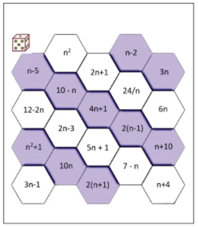
            - Teachers can use hexagon calculation games to do practice of algebraic expressions. Hexagon puzzle is an algebra challenge that can be played by multiple players. It involves rolling a dice to work out the value of an algebraic expression. Students take turns rolling the dice and the number rolled becomes the value of ‘n’. The player then gets one chance to choose a hexagon and solve the equation using the assigned value of ‘n’. At the end of the game, the student with the most number of solved hexagons wins.
Figure SEQ Figure \* ARABIC 7[Hexagon Calculation Game] [prodigygame]

Figure 7 [Hexagon Calculation Game] [prodigygame]
            - Teacher can share following online game links to practice algebraic expressions
https://www.mathgames.com/skill/4.94-write-variable-expressions
https://www.mathgames.com/skill/6.9-evaluate-multi-variable-expressions
Reference:
Help Teachers (2021) Retrieved from: https://www.helpteaching.com/questions/157258/expand-96x7
Prodigy Game (2021) Retrieved from:
https://prodigy-website.cdn.prismic.io/prodigy-website/eb0ad3f4-7f29-4860-84dc-57932df3f9a6_hexagon.pdf

Domain: Algebra
Sub-Domain: Linear Expressions & Equations

STEP 1 _________________________________________________________
Standard: Students will be able to identify and differentiate between linear expressions and linear equations, solve linear equations and apply them in real life context.
Student Learning Outcomes: Students will be able to
- Recognize algebraic equations.
- Differentiate between linear algebraic equations and linear algebraic expressions in one variable,
- Solve linear equations and apply them in real life situations.
Knowledge:  Students will be able to know:  - Concept of equations.  - Linear equations in one variable. | Skills:  Students will  - Construct linear equations in one variable  - Solve simple linear equations involving integers, fractions and decimal coefficients.  - Solve linear equations of the type:  ax + b = c, a≠0  - Solve real life situations involving linear equations
STEP 2 _________________________________________________________
Assessments:
Formative Assessments:
Some of the types of formative assessment teacher may use are:
- Question & Answer(open and closed)
- Quick Quiz
- Learning Walks
- Projects,
- Selected responses (may include MCQs, true: false, matching short answers, fill-in-the blanks, etc.)
- Observation diaries
- Inquiry charts,
- Four Corners: Gather students in the middle of the room, and read multiple-choice questions and their possible answers aloud. Students then move to the corner that represents what they believe is the correct answer. The top left room corner can be option A, the bottom-left can be B and so on
Summative Assessments
Some of the forms of summative assessment are:
- End of Unit Test
- Class Test
- Periodic/Monthly Tests
- Mid-year Exam
- End of Year Exam
- Standardized tests.
- External Exams

Some of the sample questions that can be used as part of formative assessments are:
Ask students the following type of questions:
- Convert word statements to algebraic equations. For example: Sum of price of 3 shirts and 2 pants is Rs. 13,000
- Develop an equation with one variable and exchange it with the student sitting beside and solve it as a challenge.
Some of the sample questions that can be used as part of summative assessments are:
Ask students the following type of questions:
- Solve simple linear equations (give questions involving simple linear equations, linear equations in fractions etc)
- Translate the sentence into an algebraic equation and solve
- Twice the difference of x and 3 gives 18.
- 4 times the difference of x and 8 gives 22
- Seven more than x is equal to 21
- Product of 4 and y is equal to the sum of 2y and 8.
STEP 3 _ ________________________________________________________
Learning Activities
            - Teachers can use the following activity to explain the concept of balancing equations.
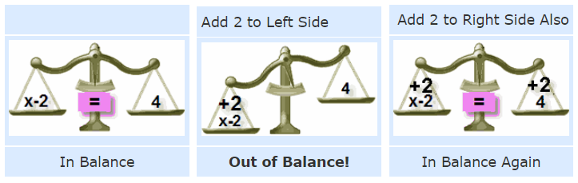
Figure 8 [Balancing Equation] [mathisfun]
            - Teachers can use Balance Math activity to do practice of algebraic equations. Students need to find out the missing number to balance the pan. When both sides weigh the same, the pan stays balanced. Working on these pan balance problems is a great way to improve logical reasoning skills.
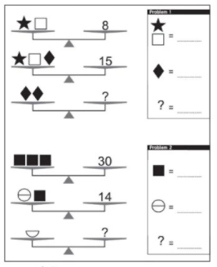
Figure 9 [Balancing Activity] [prodigygame]

            - Teachers can use riddle activity to do practice of linear equations. ‘Riddle Me’ is a fun classroom activity for students. The game can be made easy or hard depending on the equations but essentially the motive is to solve the value of each algebraic equation and find the answer to the riddle. The student who manages to solve all the equations and find the answer to the riddle wins the game!
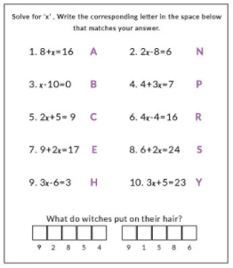
Figure 10 [Riddle Me This] [prodigygame]

            - Teachers can share the following online game links to practice algebraic equations.
https://www.mathgames.com/skill/3.75-solve-for-the-variable-with-addition-and-subtraction
https://www.mathgames.com/skill/3.76-solve-for-the-variable-with-multiplication-and-division
References:
Prodigy Game (2021) Retrieved from:
https://prodigy-website.cdn.prismic.io/prodigy-website/eb0ad3f4-7f29-4860-84dc-57932df3f9a6_hexagon.pdf

Maths is Fun (2021) Retrieved from:
https://www.mathsisfun.com/algebra/add-subtract-balance.html

Prodigy Game (2021) Retrieved from:
https://prodigy-website.cdn.prismic.io/prodigy-website/5cfc7227-ab10-448c-a1ce-583d70366ddb_balance.pdf

DOMAIN: Measurements
Sub-Domain: Surface Area and Volume

STEP 1 _________________________________________________________
Standard: Students will be able to calculate area and perimeter, surface area, volume of different 2D and 3D shapes by applying suitable formulae and units.
Student Learning Outcomes: Students will be able to
- State and differentiate between area and perimeter and their units.
- Recognize the formulae to calculate the area and perimeter, surface area, volume of different 2D and 3D shapes.
Knowledge:  Students will be able to know:  - Difference between area and perimeter.  - Formulae to calculate the area and perimeter of different shapes. | Skills:  Students will  - Calculate the area and perimeter of a rectangle, square, parallelogram, triangle and trapezium.  - Calculate the surface area and volume of cube and cuboids.  - Solve real life word problems involving perimeter, area, the surface area and volume of cubes and cuboids.
STEP 2 _________________________________________________________
Assessments:
Some of the types of formative assessment teacher may use are:
- Question & Answer(open and closed)
- Quick Quiz
- Learning Walks
- Projects,
- Selected responses (may include MCQs, true: false, matching short answers, fill-in-the blanks, etc.)
- Observation diaries
- Inquiry charts,
- Four Corners: Gather students in the middle of the room, and read multiple-choice questions and their possible answers aloud. Students then move to the corner that represents what they believe are the correct answer. The top left room corner can be option A, the bottom-left can be B and so on
Summative Assessments
Some of the forms of summative assessment are:
- End of Unit Test
- Class Test
- Periodic/Monthly Tests
- Mid-year Exam
- End of Year Exam
- Standardized tests.
- External Exams

Some of the sample questions that can be used as part of formative assessments are:
Ask students the following type of questions:
- Find the area and perimeter of their lunch boxes.
- Make the layout of their house on a grid sheet and find Area and perimeter of each room.
- Count the tiles of the room and estimate the area and perimeter of the classroom.
Some of the sample questions that can be used as part of summative assessments are:
Ask students the following type of questions:

Adriel ran 5 rounds of a square ground of side 70 m. Find the total distance he ran.
- Mrs. Rao gives one rectangular card of sides 18 cm by 14 cm to each of her 7 pupils. She wants her pupils to glue a ribbon around the border of their own card. Find the length of the ribbon they will need altogether.
- Mrs. Bell cuts a 25 cm by 6 cm cloth into 5 equal pieces. What is the area of each piece?
- Adler purchases a new house, but the main gate of the house looks ugly because of color. He measures the gate 8 feet by 10 feet. He wants to paint the main gate with white color at a cost of $20 per square foot. How much will it cost for Adler to add color to his main gate?
- What is the height of a rectangular stone with a perimeter of 260.2 mm and a base length of 75.4 mm?
- Luca has a keyboard. The length of the keyboard is 18 inches and the width is 10 inches. Find the area of the keyboard.
- A rectangular park is 54 yards wide and 110 yards long. What is its perimeter?
- Lisa wanted to paint her ugly brown flower box red. Using the given dimensions, how many square inches will she have to paint?
- David and Karen are building a tree house in the shape of a rectangular prism for their daughter. If the tree house is going to be 5 feet tall, 8 feet wide, and 7.5 feet long how much space will there be inside? How much space will they have to paint on the outside?

STEP 3 _ ________________________________________________________
Learning Activities
- Teachers can start the concept by asking students to make an anchor chart. This smart option lays out the differences and similarities between area and perimeter measurements.
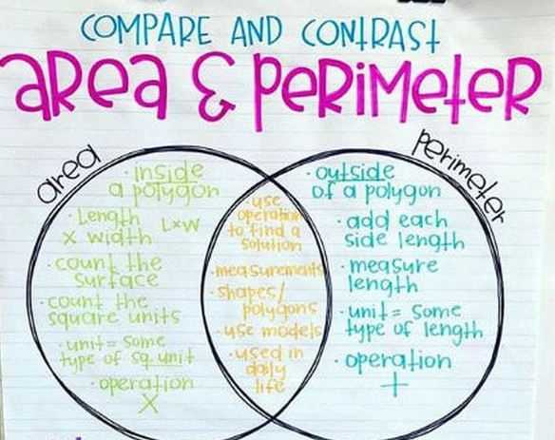
Figure 11 [Area & Perimeter] [weareteachers]
- Students can be provided a grid sheet and asked to draw themselves and find area and perimeter.
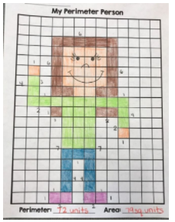
Figure 12 [Perimeter Person] [qwordfromthird]
- Teachers can also do a pair activity and can use square floor tiles to make different shapes by painter’s blue tape and can ask students to find area and perimeter.

- Teachers can share the following online game links to practice areas and perimeter.
https://www.splashlearn.com/s/math-games/find-the-perimeter-of-the-shapes-using-grids
https://www.splashlearn.com/s/math-games/find-the-perimeter-of-polygons
https://www.splashlearn.com/s/math-games/find-the-area-by-multiplying-the-side-lengths

- Teachers can ask students one day before to bring empty boxes of cube or cuboid shape in class then next day students will find the volume of those boxes.

- Teachers can share the following online game links to practice volume of cube and cuboid.
https://www.splashlearn.com/s/math-games/find-volume-using-the-formula
https://www.splashlearn.com/s/math-games/solve-the-word-problems-related-to-volume

References:

Prodigy Game (2021) Retrieved from:
https://prodigy-website.cdn.prismic.io/prodigy-website/c1c3b0cf-b7f0-4161-814a-0e9783d55f9c_riddle.pdf

DOMAIN: Geometry
Sub-Domain: Symmetry
STEP 1 ____________________________________________________
Standard: Students will be able to identify 2D, 3D shapes, parallel lines and related angles and rotational symmetry.
Student Learning Outcomes: Students will be able to
- Identify 2-D, 3-D shapes with respect to their characteristics.
- Differentiate between parallel and intersecting lines.
- Identify transversal angles related to them and recognize rotational symmetry.

Knowledge:  Students will be able to know:  - 2-D shapes (cube, cuboid, cone, cylinder, sphere, hemisphere and cone) with respect to their characteristics.  - Difference between parallel lines, perpendicular lines and transversal.  - Adjacent angles and unknown angles related to parallel lines and transversals. (corresponding, alternate and vertically opposite angles)  - Rotational symmetry. | Skills:  Students will  - Reflect an object using grid paper and compass and find the line of reflection by construction.  - Solve problems involving angles formed by two parallel lines and a transversal (corresponding, alternate, vertically opposite angles).  - Find the point of rotation and order of rotational symmetry.  Additional:  - Calculate unknown angle using the concept of angles at a point.
STEP 2 _________________________________________________________
Assessments:
Formative Assessments
Some of the types of formative assessment teacher may use are:
- Question & Answer(open and closed)
- Quick Quiz
- Learning Walks
- Projects,
- Selected responses (may include MCQs, true: false, matching short answers, fill-in-the blanks, etc.)
- Observation diaries
- Inquiry charts,
- Four Corners: Gather students in the middle of the room, and read multiple-choice questions and their possible answers aloud. Students then move to the corner that represents what they believe are the correct answer. The top left room corner can be option A, the bottom-left can be B and so on
Summative Assessments
Some of the forms of summative assessment are:
- End of Unit Test
- Class Test
- Periodic/Monthly Tests
- Mid-year Exam
- End of Year Exam
- Standardized tests.
- External Exams

Some of the sample questions that can be used as part of formative assessments are:
Ask students the following type of questions:
- Make an assignment of animal pictures with a line of reflection.
- Write their name in all capital letters and draw line of symmetry on each letter.
- Find order of rotational symmetry of 5 objects.

Summative Assessments
Ask students the following type of questions:
- Draw all the lines of symmetry in the shapes below (give different objects pictures which can have line of symmetry):
- Fill in the blanks:
- A square has ……………………. lines of symmetry.
- An equilateral triangle has ……………………. lines of symmetry.
- A line of symmetry divides an image into ……………………. equal halves.
- A scalene triangle has ……………………. lines of symmetry.
- A circle has ……………………. lines of symmetry.
- Letter H has ……………………. lines of symmetry.
- Give questions that asks for drawing lines of symmetry such as:
- Draw a shape with exactly 2 lines of symmetry. Include the lines of symmetry on your drawing.
- Draw a shape with exactly 5 lines of symmetry. Include the lines of symmetry on your drawing.
- Draw a shape with exactly 3 orders of rotation.
- Draw a shape with exactly 6 orders of rotation.
- Give questions that asks for order of rotational symmetry such as:
- What is the order of rotational symmetry of an equilateral triangle?
- What is the order of rotational symmetry of a regular pentagon?
- What is the order of rotational symmetry of a parallelogram?
- What is the order of rotational symmetry of a kite?
- Find the order of rotational symmetry of following shapes
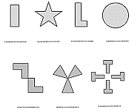
Figure 13 [Rotational Symmetry] [studylib]
STEP 3 _ ____________________________________________________
Learning Activities
- Students can be given a short activity to take color paper and fold it in half and cut any shape on its edge and observe symmetry by unfolding paper.
- Teachers can assign students to write A to Z in Capital letters and find lines of reflection in each alphabet.
- Teachers can make a worksheet with the following type of questions.
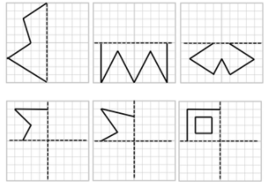
Figure 14 [line of Symmetry] [fiveways]
- Teachers can share the following online game links to practice algebraic equations.
https://www.topmarks.co.uk/symmetry/symmetry-matching
https://www.mathgames.com/skill/8.73-reflections-graph-the-image
- Teacher can use following method to explain the concept of rotational symmetry
- Students will be asked to each pick a couple of different cut out shapes and trace them on a piece of paper.
- After tracing the shapes, the students will be asked to use their pen or pencil to hold down the center of the shape and rotate the shapes and count how many times the cut out shape lined up perfectly with the traced shape (until they got to a full turn around).
- The number of times cut out will be lined to sketch in one complete rotation will be the rotational symmetry order.
- Teacher can use following link to explain the concept of rotational symmetry and point of rotation
https://www.mathsisfun.com/geometry/symmetry-rotational.html
- Teacher can share following link with students to solve a quick quiz
https://www.mathopolis.com/questions/q.html?id=849&t=mif&qs=849_850_2137_2138_3360_3361_3362_3363_5033_5034&site=1&ref=2f67656f6d657472792f73796d6d657472792d726f746174696f6e616c2e68746d6c&title=526f746174696f6e616c2053796d6d65747279#
- Teachers can ask students to write down everything they know about lines and angles. Allow a few volunteers to write one piece of information each on the board.
- Teachers can do a poster activity in which students will make columns with all the types of angles along with sketches.
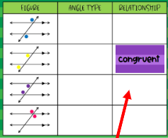
Figure 16 [Types of Angle][mrblairmaths]
- Teachers can share the following online game links to practice of angles formed by two parallel lines and a transversal.
https://www.mathgames.com/skill/8.46-transversal-of-parallel-lines
https://www.transum.org/software/SW/Starter_of_the_day/Students/AngleParallel.asp
References:
Five Ways (2021) Retrieved from:
https://www.fiveways-primary-school.org.uk/admin/ckfinder/userfiles/files/Symmetry%202.pdf

Pinterest (2021) Retrieved from:
https://www.pinterest.com/pin/283375001524974344/

Mr. Blair’s Maths (2021) Retrieved from:
https://sites.google.com/a/vusd.us/mr-blair-s-math-class/home/integrated-math-2/unit-2---lines-and-angles

DOMAIN: Geometry
Sub-Domain: Geometrical Constructions
STEP 1 ____________________________________________________
Standard: Students will be able to construct angles of different measure (with compass), bisectors of angles and bisector and perpendicular bisectors of line segments.
Student Learning Outcomes: Students will be able to
- Construct angles of different measures.
- Define bisectors of an angle, bisector and perpendicular bisector of a line segment.
Knowledge:  Students will be able to know:  - Difference between line and line segment.  - Bisector of an angle, perpendicular bisector of a line segment.  - Difference between bisector and perpendicular bisector of a line segment. | Skills:  Students will  - Construct angles of specific measures (30, 45, 60, 75, 90, 105 and 120) and bisect angles using a compass.  - Construct a perpendicular (from a point on the line and outside the line) and a perpendicular bisector.  Additional:  - find unknown angles (straight line and at a point)  - find unknown angles in a triangle (interior and exterior angles)
STEP 2 _________________________________________________________
Assessments:
Formative Assessments
Some of the types of formative assessment teacher may use are:
- Question & Answer(open and closed)
- Quick Quiz
- Learning Walks
- Projects,
- Selected responses (may include MCQs, true: false, matching short answers, fill-in-the blanks, etc.)
- Observation diaries
- Inquiry charts,
- Four Corners: Gather students in the middle of the room, and read multiple-choice questions and their possible answers aloud. Students then move to the corner that represents what they believe are the correct answer. The top left room corner can be option A, the bottom-left can be B and so on
Summative Assessments
Some of the forms of summative assessment are:
- End of Unit Test
- Class Test
- Periodic/Monthly Tests
- Mid-year Exam
- End of Year Exam
- Standardized tests.
- External Exams

Some of the sample questions that can be used as part of formative assessments are:
Ask students the following type of questions:
- Make an acute angle, an obtuse angle and a right angle and draw their angle bisectors.
- Draw 5 line segments of any measurements and draw a perpendicular bisector on each.

Some of the sample questions that can be used as part of summative assessments are:
Ask students the following type of questions:
- Find the size of each missing angle.(give images of different angles drawn on 180 or 360 degrees)
- Use your protractor to draw these angles:
40° 125° 25° 268°
- Identify which of the following pairs of angles are complementary or supplementary?
(i) 70°, 20° (ii) 20°, 170° (iii) 50°, 145° (iv) 125°, 55° (v) 105°, 75°
- Construct angle bisector of following angles. (provide images of different angles)
- Construct line bisector of following line segments:
67.8 cm 45 cm 122 cm
STEP 3 _ ________________________________________________________
Learning Activities
- Teacher can explain the concept of angle bisector by using the following activity.
- Divide the class into small groups, and provide each group with a large piece of paper, a protractor, a ruler, a pencil, and some art supplies.
- Instruct each group to make a large X on the paper by connecting the corners of the paper using two diagonal lines.
- Point out the four angles that have formed, and tell students to find and draw the angle bisector of each angle.
- Tell students that this will form additional angles, which will have their own bisectors, and so on.
- Students should continue finding bisectors until they have a given number of sections. They can then use the art supplies to color in each section for a piece of “angle bisector artwork” that looks a bit like an explosion.
- Teachers can use the following web link to show construction of angle and line bisection.
https://www.mathspad.co.uk/i2/construct.php
- Teachers can explain the concept of perpendicular bisectors by asking students to stand and make T using their arms. Teacher will explain how the body is acting as a perpendicular to their arms and the distance from their nose to tip of the finger on each side is equal.
- Teachers can share the following online quiz link of line and angle bisector.
https://www.mathgames.com/skill/8.111-measures-of-bisected-lines-and-angles

DOMAIN: Statistics and Probability
Sub-Domain: Data Management

STEP 1 ____________________________________________________
Standard: Students will be able to recognize graphs, grouped, ungrouped data continuous and discrete variables. Calculate mean, median and mode.
Student Learning Outcomes: Students will be able to
- Recognize different types of graphs.
- Differentiate between grouped and ungrouped data, continuous and discrete variables.
- Calculate mean median and mode.
Knowledge:  Students will be able to know:  - Types of graphs.  - Difference between grouped and ungrouped data, continuous and discrete variables.  - Types of formulae to calculate means. | Skills:  Students will  - Draw, read and interpret horizontal and vertical multiple bar graphs and pie charts.(including real-world problems)  - Identify and organize different types of data (i.e. discrete, continuous, grouped and ungrouped).  - Calculate the mean, median and mode for ungrouped data and solve related real-world problems.
STEP 2 _________________________________________________________
Assessments:
Formative Assessments
Some of the types of formative assessment teacher may use are:
- Question & Answer(open and closed)
- Quick Quiz
- Learning Walks
- Projects,
- Selected responses (may include MCQs, true: false, matching short answers, fill-in-the blanks, etc.)
- Observation diaries
- Inquiry charts,
- Four Corners: Gather students in the middle of the room, and read multiple-choice questions and their possible answers aloud. Students then move to the corner that represents what they believe are the correct answer. The top left room corner can be option A, the bottom-left can be B and so on
Summative Assessments
Some of the forms of summative assessment are:
- End of Unit Test
- Class Test
- Periodic/Monthly Tests
- Mid-year Exam
- End of Year Exam
- Standardized tests.
- External Exams

Some of the sample questions that can be used as part of formative assessments are:
Ask students the following type of questions:
- Make a pie chart of time they spend out of 24 hours in following activities: Studying, Playing, Eating, Sleeping and Other Activities.
- Collect data of ages of 10 people and find the mean of that data.
- Find the median of the first 12 prime numbers.

Some of the sample questions that can be used as part of summative assessments are:
Ask students the following type of questions:
- Find the mean of the following data.
(a) 9, 7, 11, 13, 2, 4, 5, 5
(b) 16, 18, 19, 21, 23, 23, 27, 29, 29, 35
(c) 2.2, 10.2, 14.7, 5.9, 4.9, 11.1, 10.5 (d) 11/4, 21/2, 51/2, 31/4, 21/2
- Find the mean of the first ten whole numbers.
- Find the mean of the first 5 prime numbers.
- The mean of 8, 11, 6, 14, x and 13 is 66. Find the value of the observation x.
- The weights in kg of 10 students are given below:
39, 43, 36, 38, 46, 51, 33, 44, 44, 43
Find the mode of this data. Is there more than 1 mode? If yes, why?
- Find the median of the following data.
27, 39, 49, 20, 21, 28, 38
10, 19, 54, 80, 15, 16
47, 41, 52, 43, 56, 35, 49, 55, 42
12, 17, 3, 14, 5, 8, 7, 15
- The number of bed-sheets manufactured by a factory during five consecutive weeks is given below. Represent the data using the bar graph. (provide a table with weeks and number of bedsheets provided in it)
- The number of students in 7 different classes is given below. Represent this data on the bar graph. (provide a data in a table with class and number of students given in it)
- The population of a particular state in different years is given below. Represent this data on the bar graph. (Provide a data in a table with years and population figures provided in it)
- The following table shows the mode of transport used by 400 students of a school. Represent the following information on the pie chart. (Provide a data in a table with mode of transport and number of students mentioned in ti)
- The percentage of expenditure of a company under different heads is as follows. Represent the following information on the pie chart. (Provide a data with heads of expenditure being salary, electricity, conveyance and machines and percentages given as 45%, 20%, 10% and 25% respectively)
STEP 3 _ ________________________________________________________
Learning Activities
- Teachers can use skittles to explain the concept of bar graph in the following way. Teachers can ask several questions through which students will learn the interpretation of bar graphs. For example: which color skittle do you have the most? Which color skittles do you have in the same number? Etc.
- Teachers can share the following online game link of interpreting and constructing bar graphs.
- https://www.splashlearn.com/s/math-games/answer-how-many-more-or-less-using-bar-graphs
- https://www.splashlearn.com/s/math-games/create-bar-graphs
- https://www.splashlearn.com/s/math-games/analyze-and-represent-data-using-bar-graph
- Teachers can explain the method of constructing a pie chart by gathering data from students. Data can be gathered by asking students how many students like to read Comic books, Poem books, Story books and Puzzle books.
- Teachers can assign students to make a pie chart of the favourite flavors of ice-cream for the children in a locality. Draw the pie chart to represent the given information. (Provide a dat in a table with ice cream flavours and percentages of students who like them mentioned in it.
- Teacher can share following online game link of interpreting and constructing pie chart
https://www.transum.org/software/SW/Starter_of_the_day/Students/Pie_Charts.asp
- Teacher can ask students to find mean and median of following data sets:
- First 10 even numbers
- Odd numbers between 50 and 70
- Multiples of 15 below 100.
- Teachers can share the following online quiz link of finding mean, median and mode.
https://www.mathgames.com/skill/7.90-interpret-charts-to-find-mean-median-mode-and-range
References:
Pinterest (2021) Retrieved from:
https://www.pinterest.com/pin/124763852166566344/

Domain: Statistics and Probability
Sub-Domain: Probability

STEP 1 _ ________________________________________________________
Standard: Students will be able to understand the concepts relating to probability.

Student Learning Outcomes: Students will be able to
- Explain experiments, outcomes, sample space, events, equally likely events and probability of a single event.
- Differentiate the outcomes that are equally likely and not equally likely to occur.(including real-world word problems).
Knowledge:  Students will be able to know:  - Experiments, outcomes, sample space, events, equally likely events and probability of a single event.  - Difference between the outcomes that are equally likely and not equally likely to occur. | Skills:  Students will  - Explain experiments, outcomes, sample space, events, equally likely events and probability of a single event.  - Differentiate the outcomes that are equally likely and not equally likely to occur.  - Apply the probability concepts to real life situations.
STEP 2 _________________________________________________________
Assessments:
Formative Assessments
Some of the types of formative assessment teacher may use are:
- Question & Answer(open and closed)
- Quick Quiz
- Learning Walks
- Projects,
- Selected responses (may include MCQs, true: false, matching short answers, fill-in-the blanks, etc.)
- Observation diaries
- Inquiry charts,
- Four Corners: Gather students in the middle of the room, and read multiple-choice questions and their possible answers aloud. Students then move to the corner that represents what they believe are the correct answer. The top left room corner can be option A, the bottom-left can be B and so on
Summative Assessments
Some of the forms of summative assessment are:
- End of Unit Test
- Class Test
- Periodic/Monthly Tests
- Mid-year Exam
- End of Year Exam
- Standardized tests.
- External Exams

Some of the sample questions that can be a part of formative assessments are:
Ask students the following type of questions:
- Write five things which they are likely to do in a day and 5 things they are unlikely to do in their complete day.
- Write 7 events which will have zero chances to happen.

Some of the sample questions that can be used as part of summative assessments are:
Ask students the following type of questions:
- If the spinner is spun once, determine whether it is certain, likely, unlikely, or impossible that the pointer stops on a number that is a multiple of 3.
- Which outcome is least likely when spinning the arrow on this spinner?
- A spinner is divided into 10 equal sectors numbered 1 through 10. If the spinner is spun, is it certain, likely, unlikely, or impossible that it lands on a number less than 4?
- What is the probability of rolling a number which is greater than 6 on a fair die?
- There are 15 letter tiles in a bag: six tiles are labeled S, eight tiles are labeled R, and one is labeled M. Which of the following describes how likely it is to choose the letter M?

STEP 3 _ ________________________________________________________
Learning Activities
- Teachers can give the concept of probability by making a concept map and by using real life events.
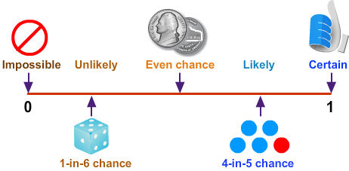
Figure 18 [Probability Line] [mathsisfun]
- Teachers can make a maze handout of probability for students to practice probability.
Teachers can share the following online quiz link of probability.
Figure SEQ Figure \* ARABIC 19 [Probability Maze] [tes]
https://www.ixl.com/math/grade-3/certain-probable-unlikely-and-impossible
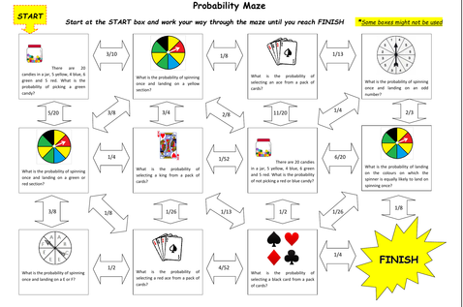
http://www.scootle.edu.au/ec/viewing/L118/index.html#
References:
Math is Fun (2021) Retrieved from:
https://www.mathsisfun.com/data/probability.html

TES (2020) Retrieved from:
https://www.tes.com/teaching-resource/probability-maze-activity-11787241

